Supplementary Materials for

A new radiometric timescale challenges the chronology of the iconic 1992 Guliya ice core

Shugui Hou *et al.*

Corresponding author: Shugui Hou, [shuguihou@sjtu.edu.cn](mailto:xxxxx@xxxx.xxx)

**The PDF file includes:**

Materials and Methods

Figs. S1 to S15

Tables S1 to S7

References and notes 48-

**Other Supplementary Materials for this manuscript include the following:**

Data S1

Materials and Methods

**The GP1992, GP2015 and GP2021 ice cores**

The Guliya ice cap, situated on the south slope of the west Kunlun Mountains in the northwest Tibetan Plateau, is the largest continental-type (cold) ice cap in central Asia (Fig. 1, Fig. S1). Climatologically, the ice cap is under the competitive influences of westerly winds and northerly winds from June to September, while it is primarily affected by westerly winds from October to May (*50*). Based on the monthly meteorological data extracted from the 10-km-resolution High Asia Refined reanalysis version 2 (HAR v2) (*51*), the mean annual temperature at the Guliya Plateau (GP) is -14.1°C, and the mean annual total precipitation is ~642 mm, with ∼44.5% of precipitation falling in winter/spring (December–May, or DJFMAM) and ∼55.5% in summer/autumn (June–November, or JJASON; Fig. S2).

GP1992 core (308.6 m in length) was drilled in July/August 1992 C.E. (*1*), and GP2015 core (309.7 m in length) in September/October 2015 C.E. (*6*). In May 2021 C.E., we revisited the Guliya ice cap and retrieved a new ice core (GP2021) with a length of 175.10 m (35°13′48.91″N, 81°28′0.07″E, 6061 m a.s.l.) on the Guliya Plateau close to the GP1992 and GP2015 drilling sites (Fig. 1C, Fig. S1) with an electromechanical drill. The measured temperature at 10 m depth of the GP2021 borehole was -13.4°C.

**Stable isotopes of water samples**

The GP2021 ice core was cut with a resolution of ~5 cm/sample, resulting in a total of 3515 samples. The water samples were analyzed for the composition of stable isotopes by Wavelength Scanned Cavity Ring-Down Spectrometer (WS-CRDS, Picarro, USA, model: L2140-i) at Nanjing University. Measured stable isotope ratios are reported in the delta notation as:

*δ $\text{ = }\left[\frac{{\text{R}}_{\text{sample}}}{{\text{R}}_{\text{reference}}}\text{-1}\right]\text{×1000}$ (S1)*

where R indicates the ratio between the heavier and lighter isotope (e.g. for oxygen, 18O/16O), providing the per mil (‰) deviation from a reference standard, which for isotopes of water being the Vienna Standard Mean Ocean Water (VSMOW). Each sample was measured ten times, with the first four measurements discarded to eliminate memory effects. The mean value of the last three measurements was taken as the final result. The analytical precision is better than 0.1‰ for δ18O (*53*).

**Tritium horizon**

Analysis of tritium was carried out on the GP2021 core, with 20 samples collected continuously from a depth range between 8.4-12.4 m (corresponding to a sampling resolution of 0.2 m/sample). Aliquots of 10 mL from the melted samples were analyzed at the Paul Scherrer Institute (PSI, Switzerland) using low-level scintillation counting (liquid scintillation counter, LSC: TriCarb 2770 SLL/BGO, Packard SA) by direct measurement. The samples were measured with a total count-time of 600 min in three cycles. The analytical limit of detection (LoD) was 1.5 Bq L-1 (12.7 TU). The measured activity concentration for samples below 10.5 m depth resulted in activity concentrations <LoD. Note that all 3H data presented in this work were decay-corrected to the reference year 1963 C.E. (*i.e.*, corrected for the decay between 1963 and Nov 2021, the time of measurement). The profile of tritium activity concentrations in the GP2021 core is shown in Fig. S5.

**210Pb dating**

The accessible time range using radioactive isotope 210Pb dating is ~150 years due to the 22.3 years half-life of 210Pb (T*1/2=*22.3 years), a product of the natural 238U decay series. Here 210Pb dating was performed on the GP2021 ice core, with a total of 32 samples collected continuously in 1 m resolution from depths between 0.5-32.5 m (Table S1).

Each sample (between 186-193 g) was cut in a -20 °C cold room. The samples were then processed and measured at PSI, following the method and approach established by Gäggeler et al. (*23*). In brief, 210Pb concentration activity was measured using *α*-counting of its grand-daughter 210Po which reaches secular equilibrium with 210Pb ∼1½ years after deposition. The samples were melted over-night after adding 0.05% (V:V) of HCl (30%). Afterwards, 100 *μ*L of a 209Po standard with known activity was added to the solution. Deposition of Po on an Ag disk (15 mm diameter) covered on one side to prevent from deposition on the back, fixed on a wire and immersed in the liquid, was achieved over ~7 hours at 95 °C in an Erlenmeyer flask, continuously mixing using a magnetic stirrer. Reducing condition were then established by bubbling SO2 gas through the liquid for minutes. After drying, the disks were positioned in vacuum chambers at a distance of 1 mm from silicon surface barrier detectors (ORTEC, ruggedized, 300 and 450 mm2) having an α-energy resolution of ~23 keV full width at half-maximum at 5.3 MeV. The 209Po standard was measured via its well separated 4.9 MeV *α*-line and finally used to determine chemical yield of deposition (73±11 %). The overall yield including detection efficiency was 22±4 %. Counting times, dependent on the activity of the sample, were between 3-21 days. The 210Pb background from supported lead (BGD) was determined to be 1.5±0.4 mBq kg-1.

The intercept of the liner regression of ln(*y*i), ln([210Pb activity]i), and *x*i, depth in m w.e., yields the 210Pb activity concentration at the surface of 185±55 mBq kg-1 ([A0]). The corresponding slope (*s*) is 0.211±0.009. By the law of radioactive decay and the assumption of constant initial deposition and constant accumulation on average, the relationship between 210Pb activity concentration *y* and age *t* (in years since the date of drilling in 2021) is given by:

$t\text{ = }\frac{-s}{ln⁡(2)}\text{× }T_{1/2} \text{× }x$*(S2)*

Not provided in Table S1, but easy to calculate if needed, is the age of an individual samples (*t*i) corresponding to its measured 210Pb activity concentration ([Ai]):

*(S3)*

where *λ* stands for the decay constant of 210Pb (0.03114 year−1). The 210Pb activity concentration profile of the GP2021 core, as well as the age-depth relationship derived for the upper part of the core is shown in Fig. S6.

**39Ar and 85Kr dating**

For 39Ar and 85Kr dating, 12 samples collected from different depth of the GP2021 core were analyzed (Table S2). The outer layer of the ice was removed to avoid potential contamination from modern air. After this procedure each ice sample weighs about 4~6 kg. The air trapped in the ice is extracted by melting the ice inside a container after evacuation and transferring the released gases into 50 mL stainless steel holders filled with activated charcoal (3g). Extraction efficiencies higher than 95% and contamination with modern air below permil are achieved with this method at a processing time of about 30~40 min. The gas contents obtained for each sample is about 16~30 mL/kg which is consistent with gas contents retrieved from the TP (*26*). The argon and krypton were separated from the extracted air with a purification system based on titanium gettering and gas chromatography (*54*), yielding krypton purities and recoveries higher than 90%. From each ice sample we obtain about 0.6 μL STP krypton.

The argon and krypton sample were measured separately with the atom trap trace analysis (ATTA) method. The principle of the ATTA apparatus and measuring procedure has been reported in previous publications (*26*, *55*). It is a laser-based atom counting method. 39Ar (or 85Kr atoms) are selectively captured by laser beams into a magneto-optical trap, and are counted by detecting their fluorescence. Meanwhile, 38Ar (or 83Kr) (a stable isotope) is chosen as the reference and its capture rate is also measured. The measurement is cycled between the 39Ar (or 85Kr) atom counting mode and 38Ar (or 83Kr) capture-rate mode. This cycling scheme cancels the slow drifts in the capture efficiencies of the instrument.

For each sample, the radio-activity of 85Kr is denoted as R85, and the 39Ar abundance relative to modern argon of 2018 C.E. is denoted as R39. If the sample is more than 100 years old (Age > 100 a) and no contamination is present, then R85 should be close to zero (R85 = 0). The age of the sample can then be calculated as follows,

Age = -t1/2 ln(R39)/ln2 *(S4)*

where t1/2 is the half-life of 39Ar (t1/2 = 268 a).

If, however, 85Kr is found to be present, indicating contamination of modern air, then correction must be made to the relative 39Ar abundance. The relationship between the corrected 39Ar abundance R39_corrected and the measured 39Ar abundance R39_measure, both relative to the modern abundance is:

R39_measure= R39_corrected × (1-η) + R39_contamination × η *(S5)*

where η is the contamination fraction and R39_contamination is the 39Ar abundance in the contaminant. In our case the dominant contamination is the modern air which enters the ice through melting and refrozen, so R39_contamination = 1. In this case,

R39_corrected = (R39_measure-η)/(1-η) *(S6)*

The contamination fraction η can be extracted using the measured 85Kr activity R85. Following arguments similar to the above ones for 81Kr, the measured 85Kr activity should follow below,

R85_measure= R85_corrected × (1-η) + R85_contamination × η *(S7)*

where R85_corrected = 0, since the ice sample is much more than 100 years old. In our case the contamination is a modern air (we assumed the activity is around 80 ± 5 dpm/cc). So we have R85_contamination = R85_modern air. Therefore, the contamination fraction is derived as

η = R85_measure/R85_modern air  *(S8)*

There are several sources that contribute to the 39Ar uncertainties:

1) Statistical errors for atom counting of 39Ar and 85Kr. Since the atom counts for both isotopes are low (10 ~ 100), we adopt the Feldman-Cousins method to estimate these errors (*56*). We use the measured 85Kr to estimate the effect of contamination on 39Ar and apply corrections accordingly as outlined above. The correction causes additional uncertainties which is included in the calculation as well.

2) Systematic error due to the uncertainty of the half-life of 39Ar (268 ± 8 a). This error causes the calculated 39Ar ages to shift up or down together for all ice samples, therefore, it is a systematic error. This error can be corrected in the future with a more precise measurement of the 39Ar half-life. Moreover, there is a systematic age-uncertainty of about 20 years due to the uncertainty of the atmospheric 39Ar history (*57*). This error can potentially be corrected in the future with a more precise reconstruction of the atmospheric 39Ar history.

**14C dating**

**1. Samples**

14C analysis was performed on ice from the 2021 GP core, sampled from16 discrete depth intervals. From each interval, two parallel samples were cut and prepared for measurements of 14C in the water-insoluble (WIOC) and dissolved (DOC) organic carbon fraction, respectively. The results are given in Table S3.

**2. Methods**

Sample preparation and AMS measurements were carried out between Dec 2021 and Feb 2022. Samples for WIOC 14C dating were prepared following the protocol described in Uglietti et al. (*25*) with a summary outlined below. To remove potential contamination in the outer layer, decontamination of samples shipped frozen to PSI was performed by removing ~3 mm of the outer layer with a pre-cleaned stainless-steel bandsaw in a -20 °C walk-in cold room before then being thoroughly rinsed with ultra-pure water. After melting of the samples in closed, pre-cleaned jars (1 L, PETG, Semadeni), the water insoluble carbonaceous particles contained as impurities in the sampled ice were filtered onto pre-baked quartz fiber filters (Pallflex Tissuquartz 2500QAT-UP). Like the samples from the Chongce ice cores recovered in the same region (*17*), very high mineral dust content, much higher than typically observed at other sites, was observed. Except for three samples (GA100, GA133, GA234), this required filtration onto two filter punches to prevent those from clogging. An example is shown with a picture of filters in Fig. S7. Based on the findings and recommendation in Fang et al. (*28*), the previous method to remove mineral carbonates from the filter by dissolution and subsequent rinsing with ultra-pure water, was slightly adapted to increase the efficiency. Filters were acidified three times with 0.5 µL of 1 M HCl (instead of 0.2 M used previously) with the reaction time being increased from a few minutes to 15 minutes after each step. All these initial steps were performed in a class 100 laminar flow box to ensure clean conditions. At the University of Bern (Laboratory for the Analysis of Radiocarbon with AMS, LARA laboratory) the WIOC samples were then combusted under controlled conditions and temperatures in a thermo-optical OC/EC (organic carbon and elemental carbon) analyzer (Sunset Modeldoc4L, Sunset Laboratory Inc, USA). In this step, carbonate removal efficiency is further enhanced by the applied temperature of 375°C for combustion of the 14C analyzed WIOC fraction (below the carbonate combustion temperature). Being coupled to a 200 kV compact accelerator mass spectrometer (AMS, mini radiocarbon dating system MICADAS), equipped with a gas ion source and a gas interface system, 14C measurements of the CO2 produced from the WIOC fraction was performed online. In-depth details for sample preparation procedures, analytical methods, instrumentation and post-processing of data can be found in previous studies (*24*, *25*, *28*, *58*, *59*).

Samples for 14C of DOC were treated in the cold-room like the ones for WIOC, however, rinsing for further decontamination was then performed under helium atmosphere in a dedicated system for DOC analysis. Full details for the DOC method can be found in Fang et al. (*28*). In brief, DOC was converted to CO2 in a catalyzed UV oxidation reaction. In a vacuum line, the evolving CO2 was then cryogenically purified and subsequently trapped, being flame sealed in glass ampules for final AMS analysis with the MICADAS at LARA, which is coupled to an ampule cracker set-up via the same gas interface also connecting the Sunset system used for WIOC analysis.

**3. Notations and data processing**

All 14C results are expressed as fraction modern (F14C), which is the 14C/12C ratio of the sample divided by the same ratio of the modern standard referenced to the year1950 C.E. (NIST standard oxalic acid II, SRM 4990C), both being normalized to -25‰ in δ13C to account for isotopic fractionation. Daily AMS calibration was performed using sets of modern (NIST oxalic acid II, SRM 4990C, F14C = 1:3407±0:0005) and fossil standards (sodium acetate, Sigma-Aldrich, no. 71180, F14C = 0:0018±0:0005). In Table S3, both AMS F14C raw data and post-processed F14C values after corrections for procedural blank contribution, constant contamination in the AMS system (background) and cross contamination between AMS samples were applied. The overall procedural blanks were estimated using artificial ice blocks of frozen ultra-pure water, treated like environmental ice samples. For WIOC, the values applied for correction of the procedural blank were 1.3 ± 0.6 μg C (n=146) for mass carbon (mC) and 0.69 ± 0.15 (n=92) for F14C, in agreement with previously reported values (*58*,*59*). If sampled onto two filter punches, mC used for WIOC correction was 1.6 μg C, accounting for the additional contribution determined for empty, pre-baked filters. For DOC, the respective values used were 1.9±1.6 μg C (n = 42) and an F14C of 0:68±0:13 (n = 39). For the WIOC Sunset-AMS system the constant contamination is 0.91±0.18 μg C with F14C of 0.72±0.11. For the ampule cracking - AMS system used for DOC samples, the respective values are 0.06±0.18 μg C and an F14C of 0.50±0.11. AMS cross-contamination is 0.5% and 0.2% of the previous sample for the WIOC and DOC setup, respectively. All DOC results were further corrected for the contribution from 14C in-situ production (*28*). For the Guliya site latitude and elevation, an in-situ production rate of 500 14C atoms gice-1 yr-1 was applied (*60*-*62*). The average accumulation rate was estimated with 0.2±0.05 m w.e. yr-1 based on the results from the 210Pb dating (0.15 m w.e. yr-1 on average but not accounting for layer thinning) and previous results for the Guliya plateau from stake and snow pit measurements ranging from 0.14-0.22 m w.e. yr-1, with reconstructed values from the GP1992 ice core (1500-1992 C.E.) suggesting rates of more than 0.3 m w.e. yr-1 for some periods (*30*, *63*-*65*). The incorporation of in-situ 14C by DOC was considered to be 18±7% (*66*). All uncertainties provided above were fully propagated throughout data processing and reflected in final calibrated 14C ages.

**4. 14C calibration**

Final F14C values were then calibrated against the Northern Hemisphere radiocarbon calibration curve IntCal20 (*67*), extended to present with the post-bomb atmospheric curve of Northern Hemisphere zone 3 from Hua et al. (*68*). Calibration was performed using the online program OxCal v4.4.4 (*69*). Straightforward calibration is all that is required if the objects dated have no other chronological or stratigraphic information associated with them (*70*). Using WIOC or DOC for 14C dating allows sampling at any desired depth and resolution/spacing along the core. This is highly beneficial compared to a lucky finding of macrofossils - e.g., plant or insect fragments - at arbitrary depth, if material to date is found at all. One major benefit comes from the available, additional stratigraphic information of the ice archive. The first order assumption of sequential deposition and thus an increase in age with depth can be made. If done so, ideally, the validity or at least the likelihood of this assumption should be investigated particularly for layers close to bedrock; for example, by tracing of near bedrock isochrones if visible in available radar data. The samples for WIOC/DOC 14C analysis from the GP2021 core were extracted from more than 50 m above bedrock (see below for estimated ice thickness at the GP2021 drill site) and folding so high above ground, especially on a large and relatively flat plateau is very unlikely. For calibration, we therefore used the additional information of order of deposition, applying the OxCal in-built Bayesian sequence model (*71*, *72*). The calibration results are presented in Fig. S8 with numbers provided in Table S3. The calibrated 14C ages are provided as years before present (cal. BP; with BP referring to the year 1950 C.E.). They represent the median age of the calibration derived probability distribution function with the provided uncertainty indicating their 1σ range.

**Age scale development**

**1. Ice flow model description**

In addition to the performed absolute dating using multiple methods and radionuclides, the depth-age relationship of GP2021 has been investigated using the widely applied one-dimensional (1D) ice flow model (D-J model) described by Dansgaard and Johnsen (*29*). In combination with the performed absolute dating using multiple methods and radionuclides, it was then applied to derive the presented continuous chronology (GP2021 age scale). The D-J model assumes steady state conditions for the three parameters used to relate depth and time, i.e., to derive the age of the ice at given depth: the ice thickness *H*, the average annual net accumulation rate *b*, and the shear zone thickness *h*. The model uses an approximation of horizontal ice flow velocities to calculate the vertical strain rate (thinning of annual ice layers with depth) by assuming the flow velocity described by Glen’s law to be constant from the glacier surface down to a given height above bedrock, from where it is then linearly decreasing with depth to zero at the bed. This depth is denoted as the shear zone thickness *h* (other expressions such as “thickness of bottom shear layer” or “kink height” were also used in the literature).

**2. Exploring of the model parameter space**

Due to their mathematical simplicity, 1D ice flow models allow for relatively straight forward optimization of parameters to achieve a best fit to dated layers (a wealth of approaches and applications can be found in the literature). In this study, optimization of parameters was achieved by minimization of the misfit between the D-J modelled ages and those of the empirically dated layers for least sum of time-weighted squares of residuals (*73*) with a Generalized Reduced Gradient algorithm (GPR) for nonlinear optimization (Excel Solver). To explore the parameter space and robustness of modeling results, (a) pre-set values based on glaciological information were used, or (b) parameter values were derived by optimization to different sets of results obtained by the absolute dating methods (“free” parameter setting) to also test for consistency between them. Input data and a summary of modeling experiments can be found in Tables S4 and S5, respectively, with details provided in the following.

**a)** For *H*, we used pre-set values based on glaciological and dating independent information. The ice thickness at the GP2021 drill site was estimated with 230 m from contour mapping of the ground penetrating radar measurements (GPR) published in Kutuzov et al. (*22*) with data available from the NOAA Paleo data repository. The uncertainty of this estimate is likely in the order of 30 to 40 m (Fig. S9). To explore a large range of possibilities, we also considered the bedrock depths of the GP1992 (309.7 m) and GP2015 ice cores (308.6 m), applying a pre-set value of 310 m. For *h*, the theoretically possible maximal range is 0<*h*≤ *H*, thus the “free” setting was constrained accordingly. For *h*=0, the D-J model yields the same solution as the Nye model (*74*), resulting with younger ages at depth compared to a value >0. For high-altitude glaciers, to our knowledge only one study did some investigation to derive an estimate for *h*. Gabrielli et al. (*75*) found *h*≈0.6\**H* to be a good solution for a high-altitude ice core drill site in the European Alps (Mt. Ortles). They showed that with this value estimate, the resulting horizontal velocities from the D-J model closely agree with measurements. Accordingly, as a dating independent value of *h*, it was accordingly pre-set to *h*=0.6\**H*. Based on their observations, Gabrielli et al. (*75*) also hypnotized a generally applicable value of *h* might be derived from the depth at the firn-ice transition, where density reaches a value of ~0.85 g cm-3. In agreement with the observed absence of an extended firn pack around the drill site in the 2021, densities around this value are reached within the first meter of the GP2021 ice core, what would suggest h≈H to be a good estimate for this site, see (b) below. Using different datasets, summarized in Tables S4 and S5 and discussed below in more detail, the parameter for the annual net accumulation rate *b* was then optimized, to find best solutions.

**b)** Different datasets were used for parameter optimization of either *b* only (see above), *h* and *b*, or all three parameters *H*, *h*, and *b*. The data was selected to allow investigating the dating results of the different dating methods in combination (full data set), but also individually for the results from 39Ar and 14C dating (with the age from 3H analysis considered in all cases for sufficient model constrain at shallow depths). To take potential limitations of the 39Ar and 14C dating methods into account, two sub-sets of each were used for parameter optimization in addition. Based on the half-life time of 39Ar, dating is applicable for samples in the age range from around 0 to 1800 a BP (*26*). Therefore, this method is likely best suited for the samples down to around 120 m depth. 14C results for that depth range might be questionable considering the possibility that bias from carbonate contribution cannot be entirely excluded despite the improved methodology. Vice versa, 14C results are likely more accurate than results from 39Ar for depth >120 m, considering the potential age of samples and the fact that 14C of DOC and WIOC is most consistent for this deeper depth interval, indicating robust results.

**3. Modeling results and GP2021 age scale**

Results for the modeling experiments are summarized in Table S5 and modeling results of the age-depth relationship are shown in Fig. S10 and Fig. 2A. For *H*, the values derived from optimization to fit to the absolute dating results were between 251 m and 270 m, with one exception yielding 310 m (for the full 14C dataset). This is within, or close to the upper ice thickness of 270 m estimated from the contour mapping of the available GPR data (Fig. S9). Values for *h* resulted with *h*=*H* (again with one exception; 0-20 m derived using the full 39Ar dataset for optimization). This agrees well with the hypothesis for a good estimate being the depth of the firn-ice transition from ref. *75*. The values derived for *b*, in the range from 0.12-0.21 m w.e. yr-1, agree with the values reported in previous studies for accumulation rates on the Guliya Plateau observed in more recent times of 0.14-0.23 m w.e. yr-1 (*30*, *63*-*65*, *76*). A few reconstructions back in time exist, based on earlier ice cores extracted from Guliya. However, they only cover the past 500 years (back to 1500 C.E.). Reconstruction shows no trend for this period as reported in Thompson et al. (*30*), with an average of around 0.25 m w.e. yr-1 and variations between <0.1 and around 0.4 m w.e. yr-1. On the other hand, the reconstruction from ref. *76*, indicates a significant trend of increasing net accumulation rates from ~0.5 m w.e. yr-1 in 1500 to ~0.2 m w.e. yr-1 in 1992 C.E.. These generally higher rates should be reflected in a younger dating compared to the results obtained in this study for the depths covering these past ~500 years, which is consistent with what is observed comparing the GP2015 with the new GP2021 age scale described next. For this youngest section of the cores, the discrepancy between the ages scales is also moderate (in good agreement for the past ~200 years) compared to the deviation before (Fig. 2A). Because a steady state model is unable to reflect changes in annual net accumulation rates, the GP2021 age scale was derived allowing for modest variability in annual net accumulation rates (smoothed 5-point running mean resulting with *b*=0.16±0.03 m w.e. yr-1) with *H*=250 m and *h*=*H*. This yields a better fit of the model to the absolute dating results, in particular for the uppermost section, where dating is solidified by 210Pb, 39Ar and 85Kr dating.

**δ18O of O2**

**1. Analytical method**

A total of 73 ice core samples from 30 discrete depths between 15.7 m to 174.5 m of GP2021 were analyzed for δ18O, δ15N, δO2/N2 and δAr/N2 of trapped air (Table S6). Approximately 20 to 40 g of ice samples were cut in the –20 $°$ C walk-in cold room at Shanghai Jiao Tong University. 2-3 mm of surface ice was trimmed away. For each depth two or three parallel samples were cut to allow for duplicate or triplicate analyses.

The isotopic and elemental ratios of ice core trapped air were measured using a melt-equilibrium method (*77*, *78*). Each ice sample was placed in a flask immersed in a cold ethanol bath (-30 $°$ C). The flask was evacuated for 10 minutes until the internal pressure dropped to ~10-5 mbar. The sample flask was then sealed before melting the ice at room temperature (22 $°$ C) for release of the trapped air. Afterwards, the flask was placed on a shaker table for one hour to equilibrate gases in melt water and headspace. After discarding the melt water, the sample flask was connected to a vacuum line. The bottom of the flask was immersed in a cold ethanol bath (–30 $°$ C) to freeze any remaining water. The air was released and passed through two traps at liquid nitrogen temperature (–196 $°$ C) to remove water vapor and CO2. Finally, the remaining gas was collected in a sample finger filled with silica-gel particles (Sigma-Aldrich, 6-14 mesh), and then heated and released into a dual-inlet isotope ratio mass spectrometer (Thermo Fisher Delta V Plus) for measurement of δ15N, δ18O, δO2/N2 and δAr/N2.

Air standards were analyzed concurrently with the samples. During the analysis period, 43 atmospheric air samples were collected in the lab courtyard. The observed long-term external precisions (1σ) for air standards were ± 0.037‰, ± 0.043‰, ± 0.2‰ and ± 0.2‰ for δ15N, δ18O, δO2/N2 and δAr/N2, respectively. The measured isotopic and elemental ratios were first corrected for the differences in the O2/N2 ratios between the sample and reference gases (*79*, *80*), and then reported relative to the mean observed values of air standards (Eq. S1).

**2. Data processing**

Isotopic and elemental ratios were corrected for gravitational fractionations according to the following equation (*81*, *82*):

$δ_{\text{atm}}=δ_{\text{measured}}-∆\text{m ∙ }δ^{\text{15}}N$ (S9)

where m is the difference in molecular weight between heavy and light gases in atomic mass units (*e.g.* 2 for 34O2/32O2, 4 for O2/N2, and 12 for Ar/N2).

To evaluate gas loss fractionations, we compared the pair differences in δ18O, δO2/N2 and δAr/N2 (i.e., the difference between the first measured sample and the second or third measured samples) for samples of the same depth. We observed a scattering of pair difference values from shallower samples and those with high δAr/N2, but no obvious trend was observed from either the δ18O – δO2/N2 or the δ18O –δAr/N2 plots (Fig. S11). This is expected because the GP2021 ice core was drilled very close to the analysis time and had not yet experienced gas losses. Consequently, no corrections for gas loss were necessary for the trapped air data of the GP2021 ice core.

**3. Depth profile of δ18O and age constraining**

From the depth profiles of trapped gas data (Fig.S12), we observed scattered and noisy δ18Oatm values in samples with high δAr/N2, especially above 100 m. Below 100 m, the reproducibility of δ18Oatm is notably high for duplicated (or triplicated) samples with δAr/N2 values close to zero. For samples above 40 m, the scattered δ18Oatm values are probably caused by partial bubble close-off.

Then, from 40 to 100 m depth, both δO2/N2 and δAr/N2 values are significantly high. This increase was induced by the seasonal melting of the ice cap (*31*). Argon (Ar) and oxygen (O2) are approximately twice as soluble as nitrogen (N2) (*83*). When surface snow melts, the gas ratios in liquid water shift towards saturation, resulting in dissolved gas δAr/N2 and δO2/N2 values of +1255‰ and 1046‰ (at 0 °C), respectively. We observed δAr/N2 and δO2/N2 values higher than 100‰ from 40 to 100 m, indicating that more than 10% of the ice core sample is constituted as melt layers. The δ18Oatm values of samples containing a high fraction of melt layers can be either positive and negative, as O2 fractionates in opposite directions for equilibrium (with a fractionation factor of + 0.7‰) and kinetic (with a fractionation factor of -2.2‰) dissolution processes. The melt-respiration correction method proposed in ref.*6* is not applicable here. Instead, we followed the method described in ref.*31*, rejecting all samples with δAr/N2 values higher than 30‰. This approach ensures that the selected samples contain melt layer fractions of less than 2-3%, significantly reducing the δ18Oatm uncertainties caused by melting.

For selected samples with δAr/N2 values less than 30‰, we observed high precisions in δ18Oatm for duplicates or triplicates samples of the same depth (pooled standard deviation = 0.025‰, N = 46). This further validates the method described in ref.*31* for dealing with Tibetan ice cores that experienced post-depositional alterations. δ18Oatm values from 100 to 174.5 m show similar isotopic compositions (mean value = 0.13 ± 0.05 ‰), with no trend observed but slightly higher than the atmospheric value of the past 3 ka (which is around zero, ref. *8*). The positive δ18Oatm value can be explained by the subtle respiration happened in various layers of Tibetan ice cores (*30*). Although the measured δO2/N2 values are very close to zero (mean value = -1.8‰), the mean δAr/N2 value is + 10.8‰. Considering the similar solubility of O2 and Ar, δO2/N2 values should also be elevated by melting. Then, respiration consumed O2 in both gas bubbles and melt layers, leading to δO2/N2 decrease to a negative value. Assuming dissolution equilibrium of O2 and Ar in melt layers, the amount of respiration consumed O2 can be estimated as:

$δO_{2}/N_{2,res}=δO_{2}/N_{2,grav}-\frac{1046‰}{1255‰}δAr/N_{2,grav}$ (S10)

Then, the magnitude of δ18Oatm increase caused by respiration could be estimated based on the close-system Rayleigh fractionation:

$δ{}_{}^{18}{O_{increase}={\left(δO_{2}/N_{2,res}/{10}^{3}-1\right)}^{α-1}}$ (S11)

where  is the oxygen isotopic fractionation factor for respiration. The mean δO2/N2,res value for selected samples below 100 m is -10.8‰, corresponding to +0.1 to +0.2‰ increase in δ18Oatm values when using an  value of 0.99 or 0.981 (*6, 31*). This magnitude explains the slightly positive δ18Oatm values we observed from GP2021.

After considering all possible post-depositional alterations, we observed δ18Oatm close to zero with no obvious trend. According to the δ18O of O2 compositions of WAIS ice core (*8*), the age of the 2021 Guliya ice core at 174.5 m is well younger than 3 ka, consistent with the radiometric timescale (Fig. 2A).

**A comparison of depth profiles in δ18Oice of the GP ice cores**

A direct comparison of GP1992, GP2015 and GP2021 δ18Oice profiles by depth is difficult due to issues related to sampling resolution and data availability. The sampling resolutions for δ18Oice measurements are ~2.4 cm/sample for GP1992 (*1*), ~3.3 cm/sample for GP2015 (*7*) and ~5 cm/sample for GP2021. The raw δ18Oice data for GP1992 and GP2015 have not been made publicly available yet, while the GP1992 δ18Oice data deposited in the online NOAA repository were averaged with resolutions of 10 m, 5 m, 3 m, 1 m and 0.6 m per point at the depth ranges of 0-100 m, 100-150 m, 150-252 m, 252-308 m and 308-308.6 m, respectively. Therefore, we extracted GP1992 δ18Oice values averaged at a resolution of 1 m per point from ref. *33* using the WebPlotDigitizer software. The GP2015 δ18Oice data were from ref. *7* but, so far, available for the top 187.4 m only, covering 41 ka. To facilitate comparison, we averaged the δ18Oice values of the GP2015 and GP2021 at a resolution of 1 m per point, and respectively matched the 1-m averaged GP2015 and GP2021 δ18Oice profiles with the 1-m digitalized GP1992 δ18Oice profile using the Match software (*34*), and the results are shown in Fig. 4.

**The GP2021 δ18Oice time series**

The δ18Oice values of GP2021 are from −25.19‰ to −2.88‰, with an average value of -15.04‰. The sampling resolution of GP2021 is ~5 cm/sample. Therefore, each δ18Oice measurement covers a temporal scale from seasonal in the ice core upper sections to over two years in the deep sections. In order to perform the time series analysis, the uneven δ18Oice series was linearly interpolated to annual resolution using MATLAB software, resulting in an annual time series of GP2021 δ18Oice back to 748 B.C.E. (Before Common Era).

We applied the Hilbert-Huang Transform (HHT) Ensemble empirical mode decomposition (EEMD) method (*84*) to separate the mode of variability for the annual GP2021 δ18Oice time series. The EEMD decomposed the record into 12 instrinsic mode functions (IMFs) loaded on different temporal scales. The composite IMFs 10-11 explain 13.6% of the total variance in the GP2021 δ18Oice time series, and reflect the long-term variation of the δ18Oice record (Fig. S13A), indicating the long-term warming trend during the past two millennia. The composite IMFs 6-9 explain 34.2% of the total variance for the GP2021 δ18Oice record, and reflect the multi-decadal to multi-centennial δ18Oice variations, showing the large δ18Oice fluctuations prior to ~800 C.E. (Fig. S13C). Spectral analysis and wavelet were also applied to determine the periodicities and periodic stabilities. The result of spectral analysis (*85*) shows dominant periodicities of around 7, 9, 15, 22, 71-78, 91-100, 120-137, 164-185, 227-294, and 345-883 years (Fig. S14).

The GP2021 δ18Oice variations at multi-decadal to multi-centennial scales (Fig. S13C) were generally consistent with the 5,200 years NAO index that was reconstructed from the lake sediment record of southwestern Greenland throughout their overlapping period (Fig. S13D, ref. *47*), with high δ18Oice values roughly encompassing the predominantly positive NAO circulation pattern, further hinting at a dynamic connection of NAO on the regional climate in the northern TP (*42*). Consistence between the GP2021 δ18Oice record and the NAO index can be remarkedly improved by matching after taking account of their age errors, it is, however, unnecessary with purpose to achieve more significant statistical results without additional absolute age control points to reduce the dating errors.

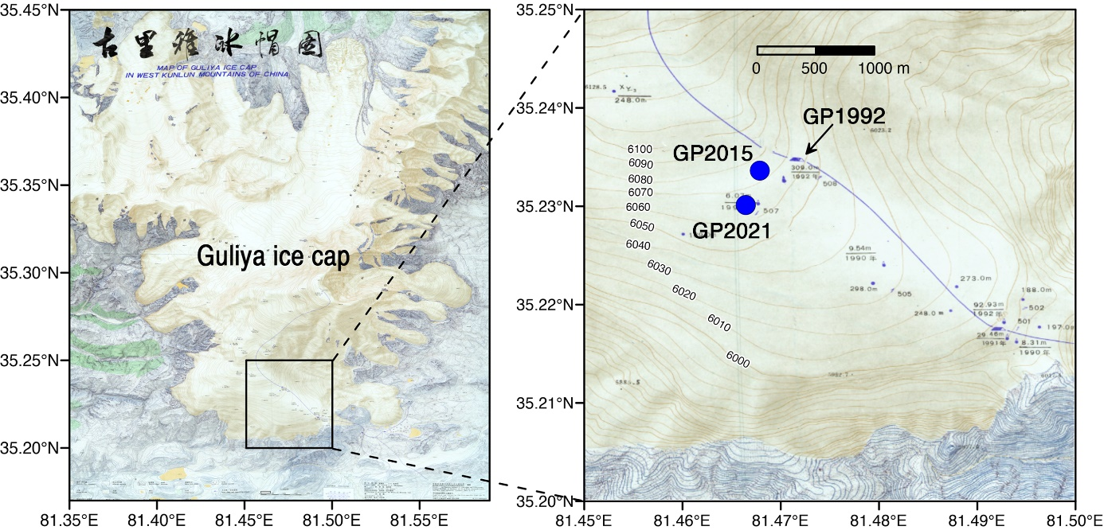

Fig. S1. Map of the Guliya ice cap in the western Kunlun Mountains. Maps adapted from ref.*52*. Accordingly, the elevation of the GP1992 drilling site is between 6060-6070 m a.s.l., consistent with the elevation of the GP2021 drilling site at 6061 m a.s.l., instead of 6200 m a.s.l. as reported in ref. *1*.



**Fig. S2. Monthly mean temperature (red dots) and monthly total precipitation (blue histogram) records in the vicinity of the Guliya ice cap during the period 1980-2022 C.E..** The temperature and precipitation data were extracted from the High Asia Refined analysis version 2 (*51*).



**Fig. S3. The 36Cl (blue line) and Cl (pink line) concentration profiles of GP1992.** The inset shows the correlation between 36Cl and Cl. The original GP1992 36Cl and Cl data were available at: <https://www.ncei.noaa.gov/access/paleo-search/study/12426>. A total of 27 samples were measured for 36Cl concentrations. The Cl concentration data were averaged with resolutions of 10 m, 5 m, 3 m, 1 m and 0.6 m per point at the depth ranges of 0-100 m, 100-150 m, 150-252 m, 252-308 m and 308-308.6 m, respectively (*1*). For correlation analysis, the Cl concentration data at the depth of 36Cl concentration samples were obtained using a simple linear interpolation (The interpolated data can be found in Table. S7).



**Fig. S4. The δ18Oice profiles of GP1992 (A) and Chongce (B) ice cores, plotted against their relative depth.** A significant positive correlation is apparent between the two δ18O profiles of GP1992 and Chongce ice cores (r=0.57, n =110, p<0.001) (*19*).

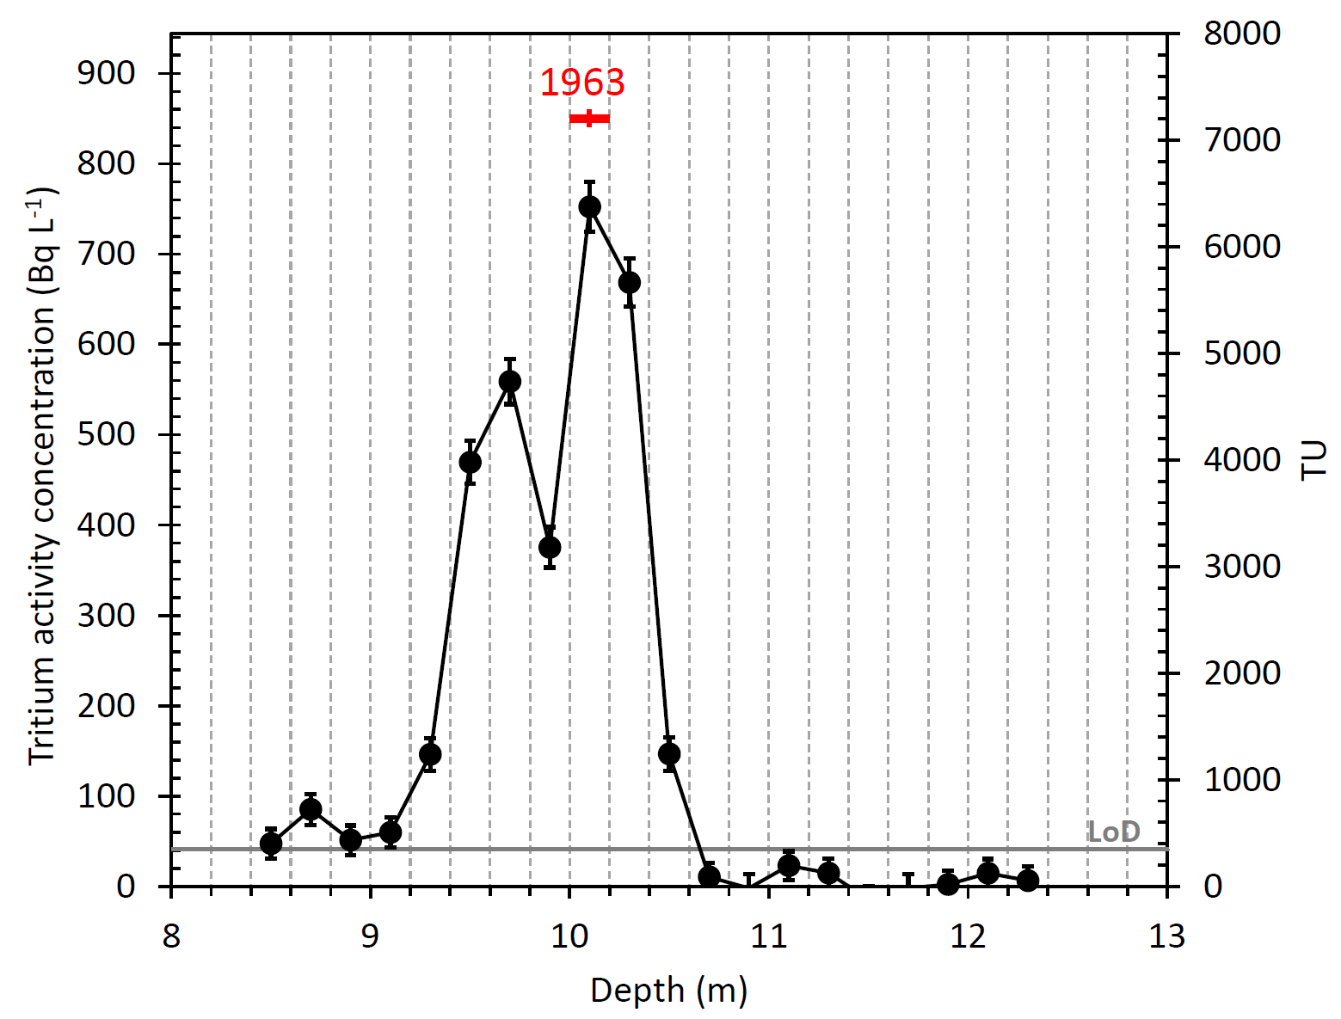

Fig. S5. Tritium activity concentration profile of the GP2021 ice core. Tritium activity concentration are shown as units of Bq L-1 (left y-axis) and Tritium units (TU, with 1 TU being 0.118 Bq L-1; right y-axis). Displayed are the activity concentrations measured 11 November 2021, corrected for the decay since 1963 (used as reference year for all samples). The analytical limit of detection (LoD) was 1.5 Bq L-1 (12.7 TU), for consistency, decay corrected for display here as well (grey line).

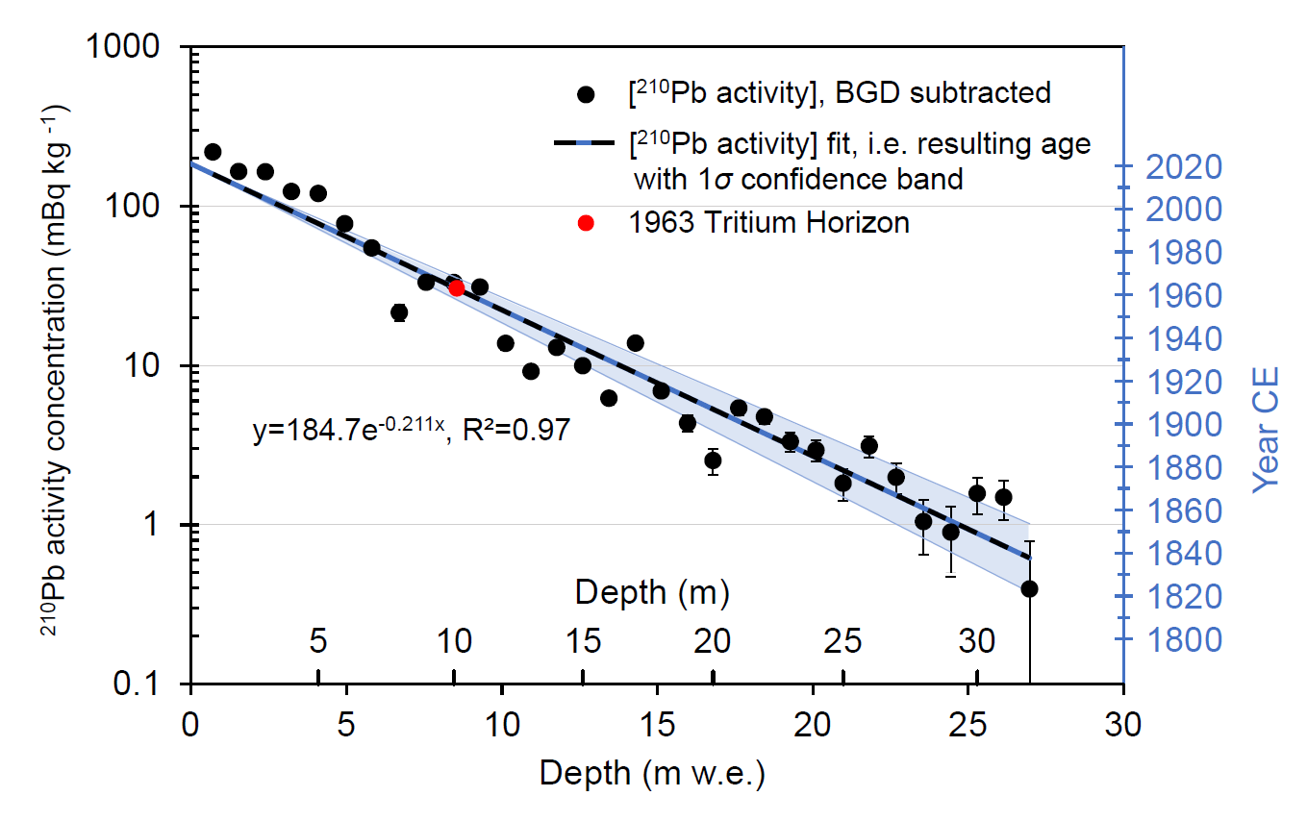

**Fig. S6. 210Pb activity concentration profile of the GP2021 ice core and the derived age–depth relationship.** The 210Pb background from supported lead (BGD; 1.5±0.3 mBq kg-1) was subtracted. Note that the confidence band relates to the right-hand y-axis only. The time horizon from 3H fallout associated with the year 1963 C.E. is in good agreement with the dating by 210Pb. Thinning of annual layers from ice deformation was not considered, following standard procedure if the fit to the data does not significantly improve otherwise. However, the presence of moderate thinning cannot be ruled out as its observation might be masked by noise in the data (scatter). Therefore, the older age limit for the deep part potentially represents a more accurate age.



**Fig. S7. Pictures of filter punches after filtration of ice samples for the extraction of WIOC and subsequent 14C analysis.** Note the much higher mineral dust content in the samples from Guliya (loaded on two separate filters to prevent them from clogging) compared to samples from a glacier (*i.e.*, Colle Gnifetti) in the European Alps shown for comparison.

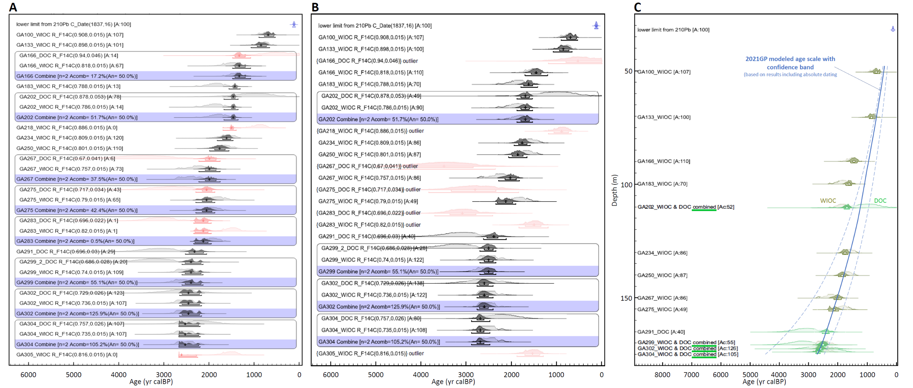

**Fig. S8. 14C calibration of the WIOC and DOC F14C results for the samples from the GP2021 ice core**. Calibration was performed in OxCal v4.4.4 (*69*) with IntCal20 and post-bomb atmospheric curve of Northern Hemisphere zone 3 from (*67*)., applying the in-built Bayesian sequence model (*71*, *72*). **(A)** Initial calibration run with enabling for calibration of combined WIOC and DOC results if available from the same depth interval (layers). A priori age probability distribution functions (PDFs) from straight forward calibration are shown in light gray, posterior PDFs for sequential constraint in dark gray, and results of statistically identified outliers in red. **(B)** Same as in panel A but with identified outliers excluded for combination and sequence when re-running the calibration algorithm. **(C)** Final results as shown in panel B against depth, also showing the subsequently derived GP2021 age scale from combining all the independent dating results from 210Pb, 39Ar and 14C by the application of a one-dimensional ice flow model (blue line with dashed lines indicating its 1σ confidence envelope). See related text in the Supplement for more details. *Additional information:* The agreement index A provided in the text line for each sample indicates the level of agreement between the a priori and posterior PDFs. Values of 100 indicate no alteration in the distribution (100% agreement or unity while values below 60 are considered critical solutions). Acomb denotes the agreement between combined results from the same layer. Combinations with Acomb < 50% also fail the chi-square test for statistically significant agreement at the 5% level. Results for which A was close to 0, or below 60 and at the same time failing the statistics for combination with the result from the other OC fraction analyzed in the same layer were considered as outliers (shown in red). Further details about the calibration algorithm and the statistics applied can be found in the OxCal online documentation (*69*), and the references provided therein.

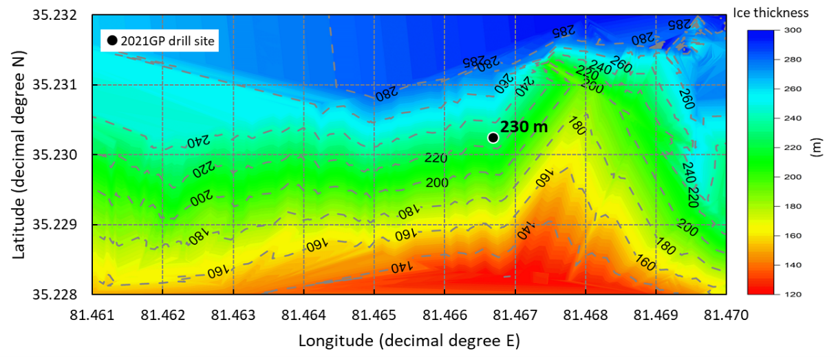

**Fig. S9.** **Contour map of ice thickness based on ground penetrating radar measurements (GPR) for the area covering the GP2021 ice core drill site.** Data from ref. *22* deposited in the NOAA Paleo data repository. The closest GPR measurement was taken around 100 m to the North of the drill site, with tracks of measurements surrounding the site. From the contour map, the ice thickness at the site can be estimated with around 230 m. The uncertainty is likely in the order of 30 to 40 m (based on the stated GPR measurement error of ±10-15 m, an estimated uncertainty of around 5 m related to a summed total of GPS position uncertainty of GPR data points and drill site, and at least 10-20 m of uncertainty arising from contour mapping, i.e., the nudging of rather distant measurement points).

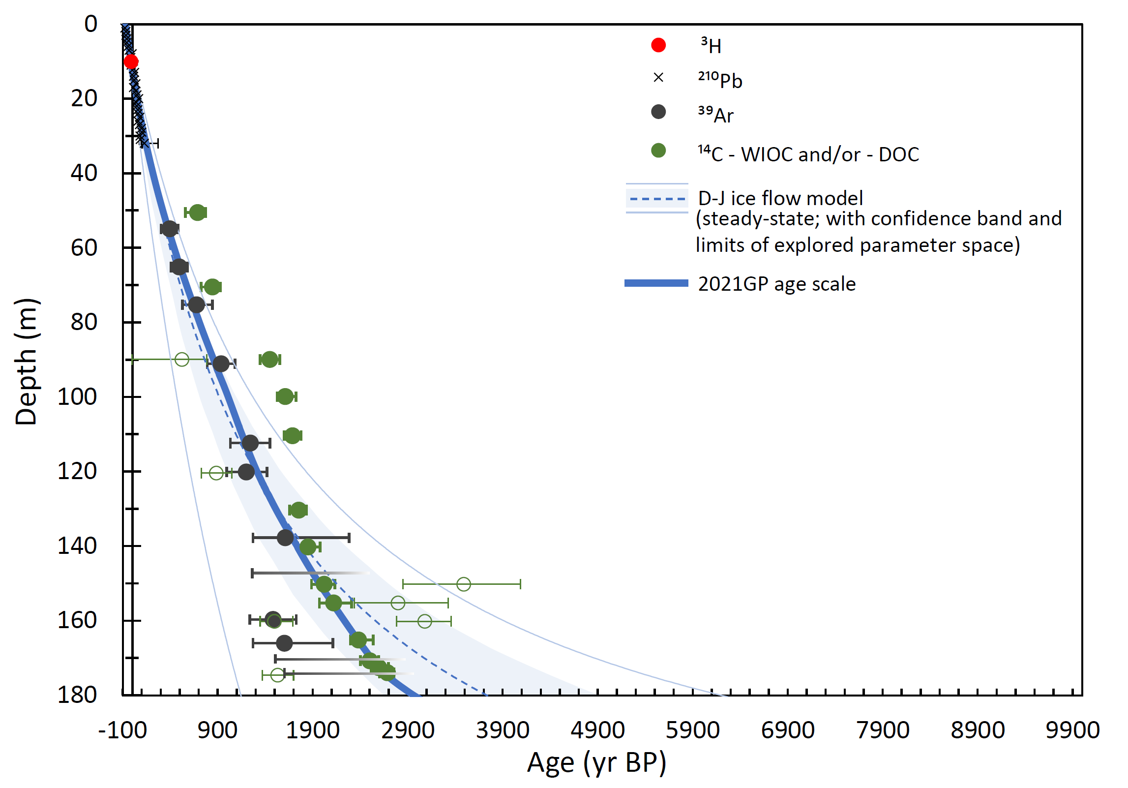

**Fig. S10.** **Dating and depth-age relationships of GP2021.** The depth-age relationship of GP2021 (in blue) based on ice flow modeling results (Dansgaard-Johnsen model, i.e., D-J model. ref, *29*). They were constrained by the shown points of ages determined by absolute dating with 210Pb, 39Ar, 14C and the 3H horizon. The GP2021 age scale (thick blue line) was derived allowing for some variability in annual net accumulation rates (*b*; *b*=0.16±0.03 m w.e. yr-1; *H*=250 m, *h*=*H*), while for the dashed line (*b*=0.15 m w.e. yr-1; *H*=250 m, *h*=*H*), and the values of the range considered in the confidence band (blue shading; *b*=0.13-0.18 m w.e. yr-1.; *H*=240-270 m, 0.9\**H*<*h*=*H*), steady state was assumed. The thin, light blue lines indicate the lower (LL) and upper limits (UL) enclosing ages derived from steady state ice flow modeling solutions for a broad range of model parameter values (LL: *b*=0.21 m w.e. yr-1., *H*=310 m, *h*=14; UL: *b*=0.12 m w.e. yr-1, *H*=230 m, *h*=*H*; see Table S5). 14C results are either from the WIOC or DOC fraction, or if possible, represent a combination of both (open symbols were considered as outliers based on the applied statistics for assumed sequential deposition, evaluated independently from the other dating methods applied; see Fig. S8). For most 39Ar samples below ~147 m depth, only a lower limit could be determined (horizontal black fading bars). This is not unexpected for samples with an age apparently at the limit of the dating range covered by this radionuclide (decay of initial activity to <5% after 5*T1/2).

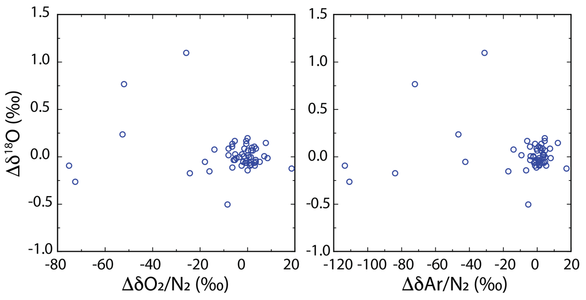

**Fig. S11.** **Pair difference plot for** δ**18O-**δ**O2/N2 and** δ**18O-**δ**Ar/N2.** All data has been corrected for gravitational fractionation. No obvious trend for gas loss can be observed.

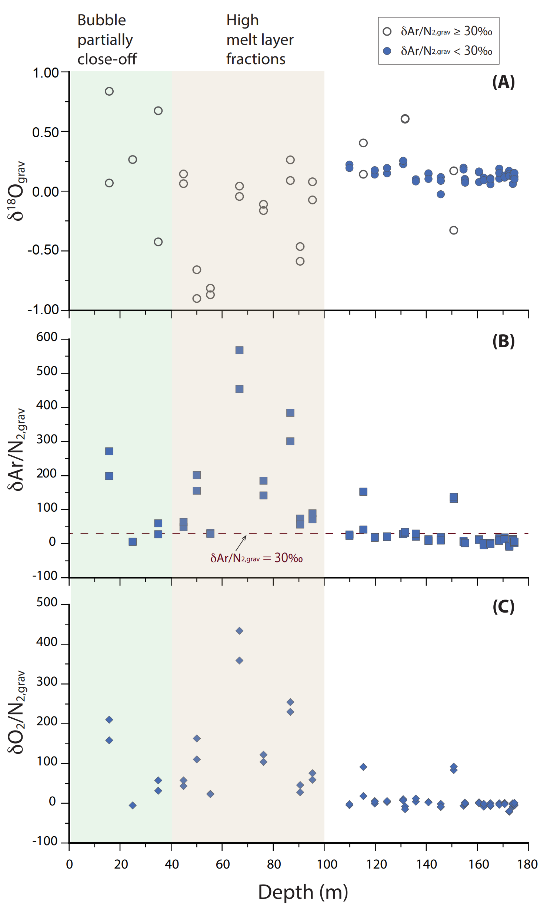

**Fig. S12. Depth profiles of analyzed trapped gases.** (A) δ18O; (B) δAr/N2; (C) δO2/N2. Filled circles in (A) represent samples with δAr/N2 values less than 30‰. Open circles represent samples with δAr/N2 values larger than 30‰, which are not considered for δ18O of O2 dating. The dashed line in (B) represents a δAr/N2 ratio equal to 30‰.



**Fig. S13.** The δ18Oice time series of the GP2021 ice core. The black line indicates its long-term trend represented by IMFs 10-11 of the EEMD analysis (*84*) (A). The high-frequency fluctuations of the GP2021 δ18Oice represented by IMFs 1-5(B). The GP2021 δ18Oice variations at multi-decadal to multi-centennial scales represented by IMFs 6-9 (C).



**Fig. S14.** Results of multitaper spectral analysis (*85*) for the GP2021 δ18Oice record. The red line stands for 95% confidence level.



**Fig. S15. The δ18Oice profile of GP2021 (blue lines) and the calcite *δ*18O record of the Kesang stalagmites from ref. *45* (black lines).** The results of GP2021 and Kesang stalagmites based on their respective original chronologies (A). The Match software (*24*) was employed to match the GP2021 δ18Oice. 30-year means profile to the Kesang *δ*18O 30-year means profile (B). The thin blue lines indicate the GP2021 annual means, and the thick blue lines indicate the GP2021 30-year means, while the thin grey lines indicate the Kesang raw data, and the thick black lines indicate the Kesang 30-year means**.**

**Table S1.** 210Pb activity concentration [A] and resulting ages for the upper part of the 2021 Guliya ice core (0.6-32.5 m depth). The 210Pb background from supported lead (BGD) was determined to be 1.5±0.3 mBq kg-1. Note that thinning of annual layers from ice deformation was not considered, following standard procedure if the fit to the data does not significantly improve otherwise. However, the presence of moderate thinning cannot be ruled out as it might be masked by data noise (precision). For the deepest depth levels, the older age limit might thus represent a more accurate age.

|  |  |  |  |  |  |  |  |
| --- | --- | --- | --- | --- | --- | --- | --- |
| Sample  # | Depth  (m) | Mid depth  (m w.e.) | [A] BGD subtracted  (mBq kg-1) | Year from fit  and law of decay  (CE) | Upper  1σ limit  (CE) | Lower  1σ limit  (CE) | Age  (yr BP) |
| 1 | 0.6 – 1.5 | 0.707 | 218.9 ± 6.3 | 2016.2 | 2016.6 | 2015.8 | $${\text{-66.2}}_{\text{-0.4}}^{\text{+0.4}}$$ |
| 2 | 1.5 – 2.5 | 1.537 | 165.1 ± 5.1 | 2010.6 | 2011.4 | 2009.6 | $${\text{-60.6}}_{\text{-0.9}}^{\text{+0.9}}$$ |
| 3 | 2.5 – 3.5 | 2.394 | 164.4 ± 5.3 | 2004.7 | 2006.1 | 2003.3 | $${\text{-54.7}}_{\text{-1.4}}^{\text{+1.4}}$$ |
| 4 | 3.5 – 4.5 | 3.232 | 123.7 ± 7.6 | 1999.0 | 2000.9 | 1997.1 | $${\text{-49.0}}_{\text{-1.9}}^{\text{+1.9}}$$ |
| 5 | 4.5 – 5.5 | 4.097 | 120.2 ± 4.7 | 1993.2 | 1995.5 | 1990.7 | $${\text{-43.2}}_{\text{-2.4}}^{\text{+2.5}}$$ |
| 6 | 5.5 – 6.5 | 4.946 | 77.6 ± 2.5 | 1987.4 | 1990.3 | 1984.4 | $${\text{-37.4}}_{\text{-2.9}}^{\text{+3.0}}$$ |
| 7 | 6.5 – 7.5 | 5.819 | 54.7 ± 2.2 | 1981.5 | 1984.8 | 1978 | $${\text{-31.5}}_{\text{-3.4}}^{\text{+3.5}}$$ |
| 8 | 7.5 – 8.5 | 6.701 | 21.5 ± 2.5 | 1975.5 | 1979.4 | 1971.4 | $${\text{-25.5}}_{\text{-3.9}}^{\text{+4.0}}$$ |
| 9 | 8.5 – 9.5 | 7.565 | 33.3 ± 1.3 | 1969.6 | 1974.0 | 1965.0 | $${\text{-19.6}}_{\text{-4.4}}^{\text{+4.6}}$$ |
| 10 | 9.5 – 10.5 | 8.458 | 33.2 ± 1.4 | 1963.5 | 1968.4 | 1958.4 | $${\text{-13.5}}_{\text{-4.9}}^{\text{+5.1}}$$ |
| 11 | 10.5 – 11.5 | 9.298 | 31.1 ± 0.5 | 1957.8 | 1963.2 | 1952.2 | $${\text{-7.8}}_{\text{-5.4}}^{\text{+5.6}}$$ |
| 12 | 11.5 – 12.5 | 10.120 | 13.8 ± 1.3 | 1952.2 | 1958.1 | 1946.1 | $${\text{-2.2}}_{\text{-5.9}}^{\text{+6.1}}$$ |
| 13 | 12.5 – 13.5 | 10.939 | 9.2 ± 0.6 | 1946.7 | 1953.0 | 1940.1 | $${\text{3.3}}_{\text{-6.4}}^{\text{+6.6}}$$ |
| 14 | 13.5 – 14.5 | 11.763 | 13.0 ± 0.7 | 1941.1 | 1947.9 | 1934.0 | $${\text{8.9}}_{\text{-6.8}}^{\text{+7.1}}$$ |
| 15 | 14.5 – 15.5 | 12.602 | 10.0 ± 0.6 | 1935.4 | 1942.7 | 1927.8 | $${\text{14.6}}_{\text{-7.3}}^{\text{+7.6}}$$ |
| 16 | 15.5 – 16.5 | 13.445 | 6.2 ± 0.5 | 1929.6 | 1937.5 | 1921.5 | $${\text{20.4}}_{\text{-7.8}}^{\text{+8.1}}$$ |
| 17 | 16.5 – 17.5 | 14.299 | 13.8 ± 1.2 | 1923.8 | 1932.1 | 1915.2 | $${\text{26.2}}_{\text{-8.3}}^{\text{+8.6}}$$ |
| 18 | 1.75 – 18.5 | 15.130 | 6.9 ± 0.6 | 1918.2 | 1927 | 1909.1 | $${\text{31.8}}_{\text{-8.8}}^{\text{+9.1}}$$ |
| 19 | 18.5 – 19.5 | 15.976 | 4.3 ± 0.5 | 1912.4 | 1921.7 | 1902.8 | $${\text{37.6}}_{\text{-9.3}}^{\text{+9.6}}$$ |
| 20 | 19.5 – 20.5 | 16.791 | 2.5 ± 0.5 | 1906.9 | 1916.7 | 1896.8 | $${\text{43.1}}_{\text{-9.8}}^{\text{+10.1}}$$ |
| 21 | 20.5 – 21.5 | 17.620 | 5.4 ± 0.5 | 1901.3 | 1911.5 | 1890.6 | $${\text{48.7}}_{\text{-10.3}}^{\text{+10.6}}$$ |
| 22 | 21.5 – 22.5 | 18.446 | 4.8 ± 0.5 | 1895.6 | 1906.4 | 1884.5 | $${\text{54.4}}_{\text{-10.7}}^{\text{+11.1}}$$ |
| 23 | 22.5 – 23.5 | 19.278 | 3.3 ± 0.5 | 1890.0 | 1901.2 | 1878.4 | $${\text{60.0}}_{\text{-11.2}}^{\text{+11.6}}$$ |
| 24 | 23.5 – 24.5 | 20.103 | 2.9 ± 0.5 | 1884.4 | 1896.1 | 1872.3 | $${\text{66.6}}_{\text{-11.7}}^{\text{+12.1}}$$ |
| 25 | 24.5 – 25.5 | 20.977 | 1.8 ± 0.4 | 1878.4 | 1890.6 | 1865.8 | $${\text{71.6}}_{\text{-12.2}}^{\text{+12.6}}$$ |
| 26 | 25.5 – 26.5 | 21.817 | 3.1 ± 0.5 | 1872.7 | 1885.4 | 1859.6 | $${\text{77.3}}_{\text{-12.7}}^{\text{+13.1}}$$ |
| 27 | 26.5 – 27.5 | 22.683 | 2.0 ± 0.4 | 1866.8 | 1880.0 | 1853.2 | $${\text{83.2}}_{\text{-13.2}}^{\text{+13.6}}$$ |
| 28 | 27.5 – 28.5 | 23.563 | 1.0 ± 0.4 | 1860.9 | 1874.6 | 1846.7 | $${\text{89.1}}_{\text{-13.7}}^{\text{+14.2}}$$ |
| 29 | 28.5 – 29.5 | 24.444 | 0.9 ± 0.4 | 1854.9 | 1869.1 | 1840.2 | $${\text{95.1}}_{\text{-14.2}}^{\text{+14.7}}$$ |
| 30 | 29.5 – 30.5 | 25.290 | 1.6 ± 0.4 | 1849.1 | 1863.8 | 1833.9 | $${\text{100.9}}_{\text{-14.7}}^{\text{+15.2}}$$ |
| 31 | 30.5 – 31.5 | 26.138 | 1.5 ± 0.4 | 1843.4 | 1858.6 | 1827.6 | $${\text{106.6}}_{\text{-15.2}}^{\text{+15.7}}$$ |
| 32 | 31.5 – 32.5 | 26.972 | 0.4 ± 0.4 | 1837.7 | 1853.4 | 1821.5 | $${\text{112.3}}_{\text{-15.7}}^{\text{+16.2}}$$ |

**Table S2. The 85Kr and 39Ar data for the 2021 Guliya ice core samples.**The given errors are 1σ SDs, whereas upper limits are given at a 90% confidence level. The measurable 85Kr abundances below 50 m, originating from contamination, are not converted to age. The raw 39Ar abundances as well as the 39Ar abundances corrected for modern air contamination are provided. The shown 39Ar ages are based on the corrected 39Ar abundances.

|  |  |  |  |  |  |  |  |  |
| --- | --- | --- | --- | --- | --- | --- | --- | --- |
| Sample # | Depth (m) | Exact depth range (m) | Weight (kg) | 85Kr (dpm/cc) | 39Ar (pMAr) | 39Ar corr (pMAr) | 39Ar age (a*) | 39Ar age final  (yr calBP) |
| 4 | 55 | 53.90 – 55.98 | 5.00 | 1.54 ± 0.16 | $${\text{35.8}}_{\text{-2.9}}^{\text{+3.2}}$$ | $${\text{34.50}}_{\text{-3.0}}^{\text{+3.2}}$$ | $${\text{433}}_{\text{-37}}^{\text{+35}}$$ | $${\text{397}}_{\text{-37}}^{\text{+35}}$$ |
| 5 | 65 | 64.21 – 66.09 | 4.92 | 0.37 ± 0.17 | $${\text{26.5}}_{\text{-2.3}}^{\text{+2.5}}$$ | $${\text{26.20}}_{\text{-2.3}}^{\text{+2.5}}$$ | $${\text{533}}_{\text{-31}}^{\text{+28}}$$ | $${\text{497}}_{\text{-31}}^{\text{+28}}$$ |
| 6 | 75 | 74.41 – 76.11 | 4.20 | 3.00 | $${\text{18.6}}_{\text{-2.1}}^{\text{+2.3}}$$ | $${\text{15.40}}_{\text{-4.0}}^{\text{+4.1}}$$ | $${\text{715}}_{\text{-87}}^{\text{+105}}$$ | $${\text{679}}_{\text{-87}}^{\text{+105}}$$ |
| 7 | 91 | 89.78 – 92.38 | 6.63 | 2.40 ± 0.22 | $${\text{10.5}}_{\text{-1.4}}^{\text{+1.6}}$$ | $${\text{7.7}}_{\text{-1.5}}^{\text{+1.7}}$$ | $${\text{973}}_{\text{-75}}^{\text{+76}}$$ | $${\text{937}}_{\text{-75}}^{\text{+76}}$$ |
| 9 | 113 | 111.46 – 113.28 | 6.81 | 1.65 ± 0.17 | $${\text{5.5}}_{\text{-1.1}}^{\text{+1.4}}$$ | $${\text{3.5}}_{\text{-1.1}}^{\text{+1.4}}$$ | $${\text{1280}}_{\text{-130}}^{\text{+130}}$$ | $${\text{1 244}}_{\text{-130}}^{\text{+130}}$$ |
| 10 | 120 | 118.98 – 121.35 | 6.22 | 0.97 ± 0.24 | $${\text{5.1}}_{\text{-1.2}}^{\text{+1.5}}$$ | $${\text{3.9}}_{\text{-1.3}}^{\text{+1.5}}$$ | $${\text{1240}}_{\text{-130}}^{\text{+140}}$$ | $${\text{1 204}}_{\text{-130}}^{\text{+140}}$$ |
| 13 | 138 | 136.75 – 138.84 | 5.40 | 2.45 ± 0.23 | $${\text{4.3}}_{\text{-0.9}}^{\text{+1.1}}$$ | $${\text{1.3}}_{\text{-1.0}}^{\text{+1.2}}$$ | $${\text{1650}}_{\text{-250}}^{\text{+580}}$$ | $${\text{1 614}}_{\text{-250}}^{\text{+580}}$$ |
| 15 | 147 | 146.23 – 148.32 | 5.31 | 0.70 ± 0.16 | < 3.8 | < 3.0 | > 1330 | > 1 294 |
| 17 | 160 | 158.74 – 160.65 | 4.95 | 0.43 ± 0.07 | $${\text{2.3}}_{\text{-0.6}}^{\text{+1.0}}$$ | $${\text{1.8}}_{\text{-0.6}}^{\text{+1.0}}$$ | $${\text{1520}}_{\text{-160}}^{\text{+160}}$$ | $${\text{1 484}}_{\text{-160}}^{\text{+160}}$$ |
| 18 | 166 | 165.02 – 167.05 | 4.94 | 1.17 ± 0.12 | $${\text{2.7}}_{\text{-0.8}}^{\text{+1.1}}$$ | $${\text{1.3}}_{\text{-0.9}}^{\text{+1.1}}$$ | $${\text{1640}}_{\text{-240}}^{\text{+420}}$$ | $${\text{1 604}}_{\text{-240}}^{\text{+420}}$$ |
| 19 | 170 | 169.20 – 171.31 | 5.29 | 0.67 ± 0.10 | < 2.4 | < 1.6 | > 1570 | > 1 534 |
| 20 | 174 | 173.07 – 175.10 | 4.92 | 0.87 ± 0.10 | < 2.3 | < 1.3 | > 1660 | > 1 624 |

*The given error for the 39Ar ages is based on the 39Ar counting statistics as well as the error from the contamination correction. In addition, there is a systematic age uncertainty of 3% due to the error of the 39Ar half-life, which would shift all 39Ar ages up or down together. This error can be corrected and improved in the future with a more precise measurement of the 39Ar half-life. Moreover, there is a systematic age uncertainty of about 20 a due to the uncertainty of the atmospheric 39Ar history (40). corr, corrected; dpm/cc, decay per minute per cubic centimeter STP of krypton; pMAr, percentage of the modern (year 2018* C.E.*) 39Ar level.*

*\***Relative to the year 2018* C.E.

Table S3. 14C dating - samples and results. 14C analyses of WIOC and DOC extracted from the GP2021 ice core. Provided are 1σ uncertainties, or for calibrated ages the 1σ range, respectively. Note that BP stands for before present, with present, per definition indicating the year 1950 CE.

|  |  |  |  |  |  |  |  |  |  |  |  |
| --- | --- | --- | --- | --- | --- | --- | --- | --- | --- | --- | --- |
| Core section # | Depth  (m) | OC fraction  analyzed | AMS Lab ID a  # | Mass ice  (g) | Mass carbon  (µg C) | Concentration (µg C kg-1) | F14CAMS raw | δ13C (‰) | F14Ccross,const,pblk£ | F14Cin-situ # | Calibrated age% (yr calBP**) |
| GA100 | 50.390-50.745 | WIOC | 17590.1.1 | 424 | 60 | 138 ± 7 | 0.903 ± 0.015 | -32 | 0.908 ± 0.015 | n/r | 687+83-127 |
| DOC | 17319.1.1 | 220 | 34 | 147 ± 8 | 1.172 ± 0.011 | -25 | 1.214 ± 0.034 | F14C > 1.1 $ | - |
| GA133 | 70.350-70.725 | WIOC | 17591.1.1 | 477 | 86 | 177 ± 9 | 0.895 ± 0.015 | -31 | 0.898 ± 0.015 | n/r | 846+84-121 |
| DOC | 17320.1.1 | 227 | 37 | 154 ± 8 | 1.230 ± 0.011 | -21 | 1.266 ± 0.034 | F14C > 1.1 $ | - |
| GA166 | 89.780-90.125 | WIOC | 17592.1.1 | 476 | 135 | 280 ± 14 | 0.816 ± 0.014 | -30 | 0.818 ± 0.015 | n/r | 1448+107-102 |
| DOC | 17321.1.1 | 223 | 31 | 131 ± 8 | 0.988 ± 0.009 | -22 | 1.014 ± 0.027 | 0.940 ± 0.046 | (524+260-525) |
| GA183 | 99.770-100.050 | WIOC | 17593.1.1 | 294 | 50 | 163 ± 9 | 0.782 ± 0.014 | -27 | 0.788 ± 0.015 | n/r | 1612+112-83 |
| DOC | 17575.1.1 | 261 | 27 | 96 ± 6 | n/d § | - | - | - | - |
| GA202 | 110.230-110.540 | WIOC | 17594.1.1 | 330 | 56 | 165 ± 9 | 0.781 ± 0.014 | -27 | 0.786 ± 0.015 | n/r | 1687+93-87 |
| DOC | 17576.1.1 | 298 | 32 | 100 ± 6 | 0.948 ± 0.010 | -20 | 0.972 ± 0.025 | 0.878 ± 0.053 |
| GA218 | 120.310-120.580 | WIOC | 17595.1.1 | 331 | 22 | 62 ± 4 | 0.868 ± 0.015 | -25 | 0.886 ± 0.021 | n/r | (884+164-155) |
| DOC | 17577.1.1 | 298 | 63 | 206 ± 7 | 1.150 ± 0.011 | -23 | 1.168 ± 0.019 | F14C > 1.1 $ | - |
| GA234 | 130.170-130.520 | WIOC | 17596.1.1 | 415 | 22 | 50 ± 3 | 0.801 ± 0.015 | -27 | 0.809 ± 0.019 | n/r | 1754+80-90 |
| DOC | 17578.1.1 | 261 | 45 | 164 ± 7 | n/d § | - | - | - | - |
| GA250 | 140.050-140.430 | WIOC | 17597.1.1 | 426 | 39 | 88 ± 5 | 0.796 ± 0.014 | -28 | 0.801 ± 0.016 | n/r | 1851+126-108 |
| DOC | 17579.1.1 | 268 | 34 | 120 ± 6 | 1.111 ± 0.011 | -16 | 1.144 ± 0.031 | F14C = 1.1 $ | - |
| GA267 | 150.060-150.350 | WIOC | 17598.1.1 | 294 | 100 | 336 ± 18 | 0.756 ± 0.014 | -27 | 0.757 ± 0.015 | n/r | 2021+113-134 |
| DOC | 17580.1.1 | 261 | 34 | 125 ± 7 | 0.737 ± 0.009 | -18 | 0.746 ± 0.015 | 0.670 ± 0.041 | (3489+598-641) |
| GA275 | 155.070-155.460 | WIOC | 17815.1.1 | 488 | 108 | 219 ± 12 | 0.784 ± 0.012 | -23 | 0.790 ± 0.013 | n/r | 2119+189-149 |
| DOC | 18396.1.1 | 246 | 40 | 156 ± 7 | 0.769 ± 0.007 | -19 | 0.778 ± 0.013 | 0.717 ± 0.034 | (2798+529-458) |
| GA283 | 160.050-160.330 | WIOC | 17817.1.1 | 348 | 57 | 159 ± 9 | 0.813 ± 0.012 | -22 | 0.820 ± 0.014 | n/r | (1496+194-151) |
| DOC | 18397.1.1 | 285 | 71 | 242 ± 7 | 0.732 ± 0.007 | -20 | 0.736 ± 0.009 | 0.696 ± 0.022 | (3081+274-298) |
| GA291 | 165.020-165.360 | WIOC | 17819.1.1 | 423 | 83 | 194 ± 10 | 0.786 ± 0.013 | -9 | n/d *&* | - | - |
| DOC | 18398.1.1 | 272 | 48 | 169 ± 7 | 0.745 ± 0.007 | -19 | 0.752 ± 0.011 | 0.696 ± 0.030 | 2383+154-85 |
| GA299 | 170.420-170.955 | WIOC | 17821.1.1 | 418 | 92 | 217 ± 12 | 0.739 ± 0.012 | -23 | 0.740 ± 0.012 | n/r | 2503+90-102 |
| DOC | 18422.1.1 | 267 | 52 | 188 ± 7 | 0.731 ± 0.007 | -18 | 0.736 ± 0.010 | 0.686 ± 0.028 |
| GA302 | 172.420-172.730 | WIOC | 17823.1.1 | 386 | 72 | 182 ± 10 | 0.734 ± 0.012 | -20 | 0.736 ± 0.013 | n/r | 2596+103-84 |
| DOC | 18400.1.1 | 279 | 60 | 208 ± 7 | 0.768 ± 0.007 | -18 | 0.774 ± 0.010 | 0.729 ± 0.026 |
| GA304 | 173.820-174.130 | WIOC | 17825.1.1 | 345 | 55 | 154 ± 9 | 0.732 ± 0.012 | -16 | 0.735 ± 0.015 | n/r | 2688+69-86 |
| DOC | 18401.1.1 | 282 | 60 | 208 ± 7 | 0.796 ± 0.007 | -21 | 0.803 ± 0.010 | 0.757 ± 0.026 |
| GA305 | 174.450-174.780 | WIOC | 17827.1.1 | 386 | 50 | 126 ± 7 | 0.811 ± 0.012 | -19 | 0.816 ± 0.015 | n/r | (1532+167-160) |
| DOC | 18402.1.1 | 257 | 209 | 805 ± 19 | n/d * | -9 | - | - | - |

*§Too low and unstable AMS 12C current. *High concentration indicating contamination from leakage of ambient air, likely during DOC extraction or analysis (supported by δ13C). £Corrected for AMS cross contamination, constant contamination (i.e., AMS background) and procedural blank. &Significantly higher than expected δ13C indicating contamination from leakage of ambient air (supported by large discrepancy in measured C mass by the Sunset after combustion, and in the AMS gas interface). #Required for DOC fraction only. See text in the Supplement. $F14C=1.1 corresponds to an age younger than 1950 CE (i.e., 0 BP), which can be excluded based on 210Pb results (analytical outliers discarded in the following). %**Median of the age probability distribution function with the provided uncertainty indicating their 1σ range. If in agreement, WIOC and DOC results were combined. Statistically identified outliers are provided in brackets. See supplement text for details.*

**Table S4. Input data for ice flow modeling and derived GP2021 age at** **corresponding depths**. Lower and upper confidence limits are denoted as LL and UL, respectively. See also Fig. S7.

|  |  |  |  |  |  |  |  |  |
| --- | --- | --- | --- | --- | --- | --- | --- | --- |
| **Dating Method** | **Sample ID** | **Mid depth** (m) | **Age** (yr BP) | **-1σ** (yr BP) | **+1σ** (yr BP**)** | **GP2021 age** (yr BP) | **LL** (yr BP) | **UL** (yr BP) |
| 210Pb* | 6 | 6.00 | -43 | -44 | -42 | -39 | -39 | -28 |
| 210Pb* | 7 | 7.00 | -32 | -33 | -31 | -33 | -34 | -21 |
| 210Pb* | 8 | 8.00 | -2 | -5 | 2 | -28 | -29 | -13 |
| 210Pb* | 9 | 9.00 | -16 | -17 | -15 | -22 | -23 | -6 |
| 210Pb* | 10 | 10.00 | -16 | -17 | -14 | -17 | -18 | 2 |
| 3H | Peak maximum | 10.10 | -13 | -14 | -12 | -16 | -17 | 3 |
| 210Pb* | 11 | 11.00 | -14 | -14 | -13 | -10 | -12 | 10 |
| 210Pb* | 12 | 12.00 | 13 | 10 | 16 | -4 | -7 | 17 |
| 210Pb* | 13 | 13.00 | 26 | 24 | 28 | 2 | -1 | 25 |
| 210Pb* | 14 | 14.00 | 15 | 13 | 17 | 8 | 5 | 33 |
| 210Pb* | 15 | 15.00 | 23 | 21 | 25 | 15 | 10 | 41 |
| 210Pb* | 16 | 16.00 | 38 | 36 | 41 | 21 | 16 | 49 |
| 210Pb* | 17 | 17.00 | 13 | 10 | 15 | 28 | 22 | 57 |
| 210Pb* | 18 | 18.00 | 35 | 32 | 38 | 35 | 28 | 65 |
| 210Pb* | 19 | 19.00 | 50 | 46 | 54 | 42 | 34 | 73 |
| 210Pb* | 20 | 20.00 | 67 | 62 | 74 | 49 | 40 | 82 |
| 210Pb* | 21 | 21.00 | 43 | 40 | 46 | 56 | 46 | 90 |
| 210Pb* | 22 | 22.00 | 47 | 44 | 50 | 64 | 52 | 98 |
| 210Pb* | 23 | 23.00 | 58 | 54 | 63 | 71 | 58 | 107 |
| 210Pb* | 24 | 24.00 | 62 | 58 | 68 | 78 | 64 | 116 |
| 210Pb* | 25 | 25.00 | 78 | 71 | 86 | 86 | 70 | 124 |
| 210Pb* | 26 | 26.00 | 60 | 56 | 66 | 94 | 76 | 133 |
| 210Pb* | 27 | 27.00 | 75 | 69 | 83 | 102 | 82 | 142 |
| 210Pb* | 28 | 28.00 | 96 | 86 | 111 | 110 | 89 | 151 |
| 210Pb* | 29 | 29.00 | 101 | 89 | 119 | 118 | 95 | 160 |
| 210Pb* | 30 | 30.00 | 83 | 75 | 92 | 126 | 101 | 169 |
| 210Pb* | 31 | 31.00 | 84 | 76 | 95 | 135 | 108 | 178 |
| 210Pb* | 31 | 32.00 | 128 | 105 | 272 | 144 | 114 | 187 |
| 14C | GA100_WIOC | 50.568 | 687 | 560 | 770 | 328 | 246 | 377 |
| 39Ar | Ar-4 | 54.940 | 395 | 305 | 483 | 378 | 280 | 427 |
| 39Ar | Ar-5 | 65.150 | 495 | 408 | 579 | 505 | 365 | 554 |
| 14C | GA133_WIOC | 70.538 | 846 | 725 | 930 | 578 | 414 | 628 |
| 39Ar | Ar-6 | 75.260 | 677 | 529 | 843 | 642 | 459 | 696 |
| 14C | GA166_WIOC | 89.953 | 1448 | 1346 | 1555 | 856 | 614 | 935 |
| 39Ar | Ar-7 | 91.080 | 935 | 791 | 1080 | 872 | 627 | 956 |
| 14C | GA183_WIOC | 99.910 | 1612 | 1529 | 1724 | 1009 | 734 | 1126 |
| 14C | GA202_combined | 110.385 | 1687 | 1600 | 1780 | 1160 | 876 | 1358 |
| 39Ar | Ar-9 | 112.370 | 1242 | 1034 | 1450 | 1189 | 906 | 1407 |
| 39Ar | Ar-10 | 120.165 | 1202 | 995 | 1419 | 1315 | 1028 | 1612 |
| 14C | GA234_WIOC | 130.345 | 1754 | 1655 | 1834 | 1517 | 1207 | 1924 |
| 39Ar | Ar-13 | 137.795 | 1612 | 1272 | 2282 | 1683 | 1356 | 2192 |
| 14C | GA250_WIOC | 140.240 | 1851 | 1743 | 1977 | 1739 | 1409 | 2288 |
| 14C | GA267_WIOC | 150.205 | 2021 | 1887 | 2134 | 1974 | 1646 | 2737 |
| 14C | GA275_WIOC | 155.265 | 2119 | 1970 | 2308 | 2108 | 1782 | 3004 |
| 39Ar | Ar-17 | 159.700 | 1482 | 1236 | 1728 | 2226 | 1911 | 3267 |
| 14C | GA291_DOC | 165.190 | 2383 | 2298 | 2537 | 2376 | 2087 | 3635 |
| 39Ar | Ar-18 | 166.035 | 1602 | 1273 | 2111 | 2401 | 2115 | 3697 |
| 14C | GA299_combined | 170.783 | 2503 | 2401 | 2593 | 2539 | 2285 | 4070 |
| 14C | GA302_combined | 172.575 | 2596 | 2512 | 2699 | 2596 | 2354 | 4225 |
| 14C | GA304_combined | 173.975 | 2688 | 2602 | 2757 | 2648 | 2409 | 4351 |

*\* Age derived for the individual data point and not the fit at given depth. See Supplement section: 210Pb dating.*

**Table S5. Exploration of the ice flow model parameter space for the GP2021 ice core drill site.** The one-dimensional ice flow model applied, the Dansgard-Jonsen model (D-J model, *28*), assumes steady state conditions for the three parameters it is built on: the ice thickness *H*, the shear zone thickness *h*, and the average annual net accumulation rate *b*. These parameters were either pre-set or optimized for a best fit to the specified data set (denoted as free). Multiple variations were explored with pre-set values based on glaciological information such as GPR based ice thickness estimates or by applying different combinations of the dated horizons from the different, independent dating methods applied to the GP2021 ice core. See Table S4 for input datasets used, and Fig. 2 and Fig. S10 for modeling results.

|  |  |  |  |  |  |  |
| --- | --- | --- | --- | --- | --- | --- |
| **Dataset used for parameter optimization** | ***H*** | | ***h*#** | | ***b*** | |
| setting | (m) | setting | (m) | setting | (m w.e. yr-1) |
| 210Pb, 3H, 39Ar, 14C | free | 275 | free | 275 | free | 0.162 |
| pre-set* | 230* | free | 230 | free | 0.185 |
| pre-set§ | 309§ | pre-set | 185& | free | 0.149 |
| 3H, 39Ar | ≤310 | 277 | free | 14 | free | 0.124 |
| ≤280 | 280 | free | 20 | free | 0.124 |
| pre-set* | 230* | free | 0 | free | 0.132 |
| 3H, 39Ar data-subset <121 m | ≤310 | 251 | free | 251 | free | 0.146 |
| ≤280 | 251 | free | 251 | free | 0.146 |
| pre-set* | 230* | free | 230 | free | 0.153 |
| 3H, 14C | ≤310 | 310 | free | 310 | free | 0.120 |
| ≤280 | 280 | free | 280 | free | 0.135 |
| pre-set* | 230* | free | 230 | free | 0.186 |
| 3H, 14C data subset >121 m | ≤310 | 277 | free | 277 | free | 0.149 |
| ≤280 | 277 | free | 277 | free | 0.149 |
| pre-set* | 230* | free | 230 | free | 0.205 |
| Full range shown in Fig. S8 |  | 230-310 |  | 14 ≤ *h* ≤ *H* |  | 0.120-0.205 |
| Confidence envelope shown in Fig. S8 | | 240-270$ | 0.9\**H* ≤ *h* ≤ *H*& | |  | 0.130-0.177£ |
| Dashed line shown in Fig. S8£ | | 250 | *h*=*H* | 250 | average | 0.153 |
| **GP2021 age scale** (non-steady state *b*) | | **250** |  | **250** | variable *b* | **0.137-0.191** |

*#The theoretically maximal range for h is 0<h≤ H (constrained accordingly in the “free” setting). *The GPR based thickness estimate for the GP2021 drill site is 230 m with an uncertainty of around 40 m (see Fig. S7). §The bedrock depth of the GP1992 ice core was 309.7 m and 308.6 m for GP2015. &Gabrielli et al. (73) found h≈0.6*H to be a good approximation for a high-altitude glacier in the European Alps, with their results suggesting h to be around the depth of the firn-ice transition (reached at ~1 m depth in GP2021, what would suggest h≈H for this site). $The GPR based ice thickness was estimated with 230 m with a maximum estimate of around 270 m. All solutions for “free” parameter setting yielded H >250 m. £The range of the average ± 1 standard deviation.*

**Table S6. Isotopic and elemental ratios of trapped air data for the GP2021.**

|  |  |  |  |  |  |  |  |  |  |
| --- | --- | --- | --- | --- | --- | --- | --- | --- | --- |
| **Sample IDa** | **Top depth (m)** | **Bottom depth (m)** | **δ15N vs.air (‰)** | **δ18O vs.air (‰)** | **δO2/N2 vs.air (‰)** | **δAr/N2 vs.air (‰)** | **δ18Oatm (‰)** | **δO2/N2, grav (‰)** | **δAr/N2, grav (‰)** |
| GARun33-1 | 15.7 | 15.75 | -0.862 | -0.886 | 154.9 | 188.5 | 0.838 | 158.4 | 198.9 |
| GARun33-2 | 15.7 | 15.75 | 0.177 | 0.421 | 211.3 | 273.3 | 0.068 | 210.6 | 271.2 |
| GARun52-1 | 24.915 | 24.965 | -2.192 | -4.118 | -14.0 | -21.0 | 0.266 | -5.2 | 5.3 |
| GARun73-2 | 34.85 | 34.9 | -0.061 | -0.547 | 57.1 | 58.8 | -0.426 | 57.3 | 59.5 |
| GARun90-1 | 44.765 | 44.815 | -0.351 | -0.558 | 42.1 | 45.0 | 0.144 | 43.5 | 49.2 |
| GARun90-2 | 44.765 | 44.815 | 0.115 | 0.292 | 58.0 | 64.7 | 0.062 | 57.5 | 63.3 |
| GY-99 | 49.99 | 50.04 | 0.261 | -0.136 | 111.0 | 158.0 | -0.658 | 109.9 | 154.9 |
| GY-99-B | 49.99 | 50.04 | 0.238 | -0.424 | 163.7 | 204.4 | -0.901 | 162.7 | 201.6 |
| GARun107-1 | 55.26 | 55.31 | -0.081 | -1.032 | 23.4 | 30.5 | -0.869 | 23.7 | 31.5 |
| GARun107-2 | 55.26 | 55.31 | -0.012 | -0.838 | 22.9 | 28.8 | -0.814 | 23.0 | 28.9 |
| GARun127-1 | 66.68 | 66.73 | 0.323 | 0.602 | 359.8 | 458.1 | -0.045 | 358.5 | 454.2 |
| GARun127-2 | 66.68 | 66.73 | 0.415 | 0.873 | 435.5 | 572.9 | 0.042 | 433.9 | 567.9 |
| GARun144-1 | 76.11 | 76.16 | 0.022 | -0.117 | 103.7 | 142.1 | -0.162 | 103.6 | 141.8 |
| GARun144-2 | 76.11 | 76.16 | 0.089 | 0.068 | 122.0 | 185.4 | -0.110 | 121.7 | 184.4 |
| GARun160-1 | 86.63 | 86.68 | 0.217 | 0.524 | 230.4 | 302.7 | 0.090 | 229.5 | 300.1 |
| GARun160-2 | 86.63 | 86.68 | 0.182 | 0.628 | 254.7 | 386.3 | 0.263 | 253.9 | 384.1 |
| GY-167 | 90.46 | 90.51 | 0.025 | -0.539 | 45.8 | 74.1 | -0.588 | 45.7 | 73.8 |
| GY-167-B | 90.46 | 90.51 | -0.002 | -0.468 | 27.3 | 56.6 | -0.464 | 27.3 | 56.7 |
| GARun176-1 | 95.33 | 95.38 | 0.188 | 0.302 | 60.0 | 73.9 | -0.073 | 59.3 | 71.6 |
| GARun176-2 | 95.33 | 95.38 | 0.146 | 0.372 | 76.1 | 90.6 | 0.080 | 75.5 | 88.8 |
| GARun201-1 | 109.84 | 109.89 | 0.157 | 0.537 | -4.0 | 28.8 | 0.224 | -4.7 | 26.9 |
| GARun201-2 | 109.84 | 109.89 | 0.129 | 0.451 | -1.7 | 25.0 | 0.193 | -2.2 | 23.5 |
| GARun210-1 | 115.27 | 115.32 | 0.175 | 0.493 | 19.0 | 43.8 | 0.143 | 18.3 | 41.7 |
| GARun210-2 | 115.27 | 115.32 | 0.232 | 0.867 | 91.9 | 155.5 | 0.404 | 91.0 | 152.7 |
| GY-217-B | 119.71 | 119.735 | -0.047 | 0.079 | 5.6 | 18.7 | 0.173 | 5.8 | 19.3 |
| GY-217 | 119.71 | 119.76 | -0.087 | -0.033 | -0.9 | 18.1 | 0.140 | -0.6 | 19.1 |
| GY-217-C | 119.735 | 119.76 | -0.097 | -0.019 | 3.9 | 17.1 | 0.175 | 4.3 | 18.3 |
| GARun225-1 | 124.54 | 124.59 | 0.126 | 0.399 | 3.7 | 21.2 | 0.148 | 3.2 | 19.7 |
| GARun225-2 | 124.54 | 124.59 | 0.099 | 0.392 | 5.6 | 22.5 | 0.193 | 5.2 | 21.3 |
| GY-235 | 130.92 | 130.97 | -0.108 | 0.009 | 10.1 | 27.6 | 0.225 | 10.5 | 28.9 |
| GY-235-B | 130.92 | 130.97 | -0.104 | 0.047 | 6.8 | 27.2 | 0.255 | 7.3 | 28.4 |
| GARun235-1 | 131.53 | 131.58 | -0.162 | 0.285 | -8.3 | 29.4 | 0.608 | -7.7 | 31.3 |
| GARun235-2 | 131.53 | 131.58 | 0.063 | 0.728 | -14.4 | 34.5 | 0.603 | -14.6 | 33.8 |
| GARun243-1 | 135.81 | 135.86 | -0.097 | -0.093 | 3.6 | 19.2 | 0.101 | 4.0 | 20.4 |
| GARun243-2 | 135.81 | 135.86 | -0.004 | 0.074 | 12.1 | 29.8 | 0.082 | 12.1 | 29.9 |
| GY-251-B | 140.83 | 140.855 | -0.115 | -0.085 | 1.6 | 6.8 | 0.145 | 2.1 | 8.2 |
| GY-251 | 140.83 | 140.88 | -0.119 | -0.087 | 2.9 | 11.3 | 0.150 | 3.4 | 12.7 |
| GY-251-C | 140.855 | 140.88 | -0.130 | -0.158 | 1.6 | 6.9 | 0.102 | 2.1 | 8.5 |
| GY-259-B | 145.57 | 145.595 | -0.051 | 0.017 | -9.6 | 12.0 | 0.119 | -9.4 | 12.6 |
| GY-259 | 145.57 | 145.62 | 0.015 | 0.004 | -1.3 | 19.8 | -0.026 | -1.4 | 19.6 |
| GY-259-C | 145.595 | 145.62 | -0.118 | -0.149 | -8.9 | 7.8 | 0.087 | -8.5 | 9.2 |
| GY-268 | 150.68 | 150.73 | 0.286 | 0.245 | 84.5 | 135.0 | -0.327 | 83.4 | 131.6 |
| GY-268-B | 150.68 | 150.73 | 0.091 | 0.353 | 92.3 | 138.1 | 0.170 | 92.0 | 137.0 |
| GARun274-1 | 154.45 | 154.5 | 0.228 | 0.655 | -5.6 | 11.1 | 0.198 | -6.5 | 8.4 |
| GARun274-2 | 154.45 | 154.5 | 0.098 | 0.376 | -6.1 | 5.7 | 0.181 | -6.5 | 4.6 |
| GY-275-B | 155.07 | 155.095 | -0.039 | 0.024 | 1.4 | 3.0 | 0.103 | 1.6 | 3.5 |
| GY-275 | 155.07 | 155.12 | -0.031 | 0.028 | -2.1 | 0.6 | 0.090 | -2.0 | 0.9 |
| GY-275-C | 155.095 | 155.12 | 0.022 | 0.114 | 0.5 | 2.0 | 0.070 | 0.4 | 1.8 |
| GY-284-B | 160.65 | 160.675 | -0.093 | -0.030 | 0.1 | 11.8 | 0.157 | 0.5 | 13.0 |
| GY-284 | 160.65 | 160.7 | 0.005 | 0.085 | 2.9 | 12.5 | 0.076 | 2.9 | 12.5 |
| GY-284-C | 160.675 | 160.7 | -0.078 | 0.011 | 0.8 | 10.4 | 0.166 | 1.1 | 11.3 |
| GY-287-B | 162.46 | 162.485 | -0.104 | -0.111 | -3.0 | 2.0 | 0.098 | -2.6 | 3.3 |
| GY-287 | 162.46 | 162.51 | -0.026 | 0.061 | -8.5 | -4.0 | 0.113 | -8.4 | -3.7 |
| GY-287-C | 162.485 | 162.51 | -0.070 | -0.049 | -1.9 | 0.4 | 0.091 | -1.6 | 1.2 |
| GY-291-B | 165.02 | 165.045 | -0.033 | -0.009 | -0.3 | 3.1 | 0.057 | -0.2 | 3.5 |
| GY-291 | 165.02 | 165.07 | 0.011 | 0.128 | -6.8 | 1.7 | 0.106 | -6.8 | 1.5 |
| GY-291-C | 165.045 | 165.07 | -0.032 | 0.038 | -5.3 | -1.4 | 0.101 | -5.2 | -1.0 |
| GY-296-B | 168.57 | 168.595 | -0.059 | 0.069 | -0.5 | 14.6 | 0.188 | -0.2 | 15.4 |
| GY-296 | 168.57 | 168.62 | -0.088 | -0.070 | -0.6 | 7.9 | 0.105 | -0.2 | 9.0 |
| GY-296-C | 168.595 | 168.62 | -0.086 | -0.020 | -3.9 | 7.3 | 0.152 | -3.5 | 8.3 |
| GY-299-B | 170.61 | 170.635 | -0.048 | 0.033 | 1.2 | 17.9 | 0.130 | 1.3 | 18.5 |
| GY-299 | 170.61 | 170.66 | -0.034 | 0.044 | -0.4 | 13.8 | 0.113 | -0.3 | 14.2 |
| GY-299-C | 170.635 | 170.66 | 0.004 | 0.123 | -1.8 | 12.8 | 0.116 | -1.8 | 12.7 |
| GY-302-B | 172.42 | 172.445 | 0.041 | 0.250 | -20.0 | -5.0 | 0.169 | -20.2 | -5.5 |
| GY-302 | 172.42 | 172.47 | 0.025 | 0.195 | -20.5 | -7.0 | 0.144 | -20.6 | -7.3 |
| GY-302-C | 172.445 | 172.47 | -0.037 | 0.054 | -19.9 | -9.3 | 0.128 | -19.7 | -8.9 |
| GY-304-B | 173.82 | 173.845 | -0.027 | 0.066 | 0.4 | 14.0 | 0.120 | 0.5 | 14.3 |
| GY-304 | 173.82 | 173.87 | 0.047 | 0.154 | -7.8 | 13.5 | 0.060 | -8.0 | 12.9 |
| GY-304-C | 173.845 | 173.87 | -0.007 | 0.128 | -2.4 | 10.3 | 0.142 | -2.4 | 10.4 |
| GY-305-B | 174.45 | 174.475 | -0.028 | 0.064 | -5.0 | 1.7 | 0.120 | -4.9 | 2.1 |
| GY-305 | 174.45 | 174.5 | -0.046 | 0.060 | -4.5 | 5.0 | 0.151 | -4.3 | 5.5 |
| GY-305-C | 174.475 | 174.5 | -0.005 | 0.090 | 1.0 | 6.1 | 0.100 | 1.0 | 6.1 |

**Table. S7. The 36Cl and Cl- concentration data of GP1992.**

|  |  |  |
| --- | --- | --- |
| Depth (m) | 36Cl (104 atoms g-1) | Cl- (ppb) |
| 10.420 | 0.210 | 472.877 |
| 13.880 | 0.149 | 461.978 |
| 40.000 | 0.213 | 526.100 |
| 62.590 | 0.313 | 537.324 |
| 82.360 | 0.242 | 463.573 |
| 136.070 | 0.271 | 559.596 |
| 170.710 | 0.289 | 842.949 |
| 178.450 | 0.326 | 808.142 |
| 179.500 | 0.234 | 808.317 |
| 180.500 | 0.291 | 784.517 |
| 181.500 | 0.329 | 736.750 |
| 182.550 | 0.323 | 686.595 |
| 183.600 | 0.452 | 673.860 |
| 184.650 | 0.234 | 689.190 |
| 185.650 | 0.295 | 703.790 |
| 186.650 | 0.319 | 662.035 |
| 204.550 | 0.246 | 575.535 |
| 218.760 | 0.220 | 635.024 |
| 223.500 | 0.155 | 607.100 |
| 239.530 | 0.211 | 586.579 |
| 249.970 | 0.231 | 541.648 |
| 254.170 | 0.217 | 491.672 |
| 263.630 | 0.240 | 446.401 |
| 286.140 | 0.179 | 674.720 |
| 291.370 | 0.186 | 578.433 |
| 296.550 | 0.117 | 446.640 |
| 305.440 | 0.054 | 96.816 |

References

1. S. Li, T. Yao, W. Yu, W. Yang, M. Zhu. Energy and mass balance characteristics of the Guliya ice cap in the West Kunlun Mountains, Tibetan Plateau. *Cold Reg. Sci. Technol.* **159**, 71-85 (2019).
2. X. Wang, V. Tolksdorf, M. Otto, D. Scherer. WRF-based dynamical downscaling of ERA5 reanalysis data for High Mountain Asia: Towards a new version of the High Asia Refined analysis. *Int. J. Climatol.* **41**, 743-762 (2020).
3. T. Yao, L. G. Thompson. Map of the Guliya ice cap in west Kunlun Mountains of China (in Chinese), Xi’an Cartographic Publishing House, Xi’an, China (1992).
4. Y. Tang, H. Pang, W. Zhang, Y. Li, S. Wu, S. Hou. Effects of changes in moisture source and the upstream rainout on stable isotopes in precipitation - a case study in Nanjing, eastern China. *Hydrol. Earth Syst. Sci.* **19**, 4293-4306 (2015).
5. X. Z. Dong, F. Ritterbusch**,** Y. Q. Chu, J. Q. Gu, S. M. Hu, W. Jiang, Z. T. Lu, G. M. Y, L. Zhao. Dual Separation of Krypton and Argon from Environmental Samples for Radioisotope Dating. *Anal. Chem.* **91**, 13576-13581 (2019)
6. W. Jiang, K. Bailey, Z.-T. Lu, P. Mueller, T. P. O'Connor, C.-F. Cheng, S.-M. Hu, R. Purtschert, N. C. Sturchio, Y. R. Sun, W. D. Williams, G.-M. Yang. An atom counter for measuring 81Kr and 85Kr in environmental samples. *Geochim. Cosmochim. Acta* **91**, 1-6 (2012).
7. G. J. Feldman, R. D. Cousins. Unified approach to the classical statistical analysis of small signals. *Phys. Rev. D* **57**, 3873 (1998).
8. J.-Q. Gu, A. L. Tong, G.-M. Yang, S.-M. Hu, W. Jiang, Z.-T. Lu, R. Purtschert, F. Ritterbusch, Reconstruction of the atmospheric 39Ar/Ar history. *Chem. Geol.* **583**, 120480 (2021).
9. T. M. Jenk, S. Szidat, D. Bolius, M. Sigl, H. W. Gäggeler, L. Wacker, M. Ruff, C. Barbante, C. F. Boutron, M. Schwikowski. A novel radiocarbon dating technique applied to an ice core from the Alps indicating late Pleistocen ages. *J. Geophys. Res.***114**, D14305 (2009).
10. M. Sigl, T. M. Jenk, T. Kellerhals, S. Szidat, H.W. Gäggeler, L. Wacker, H.-A. Synal, C. Boutron, C. Barbante, J. Gabrieli, M. Schwikowski. Towards radiocarbon dating of ice cores. *J. Glaciol.* **55**, 985-996 (2009).
11. D. Lal, K. Nishiizumi, J. Arnold. In situ cosmogenic 3H, 14C, and 10Be for determining the net accumulation and ablation rates of ice sheets. *J. Geophys. Res.-Sol. Ear.* **92**, 4947-4952 (1987).
12. D. Lal, A. Jull. On determining ice accumulation rates in the past 40,000 years using in situ cosmogenic 14C. *Geophys. Res. Lett.* **17**, 1303-1306 (1990).
13. D. Lal. Cosmogenic in situ radiocarbon on the earth. Radiocarbon After Four Decades, Springer, 146–161 (1992).

L. G. Thompson, T. Yao, M. E. Davis, E. Mosley-Thompson, G. Wu, S. E. Porter, B. Xu, P.-N. Lin, N. Wang, E. Beaudon, K. Duan, M. R. Sierra-Hernández, D. V. Kenny. Ice core records of climate variability on the Third Pole with emphasis on the Guliya ice cap, western Kunlun Mountains. *Quat. Sci. Rev.* **188**, 1-14 (2018).

T. Yao, L. G. Thompson, D. Qin, L. Tian, K. Jiao, Z. Yang, C. Xie. Variations in temperature and precipitation in the past 2 000 a on the Xizang (Tibet) Plateau-- Guliya ice core record. *Sci. China -Ser. D* **39(4)**, 425-433 (1996).

Y. Shi, T. Yao, B. Yang. Decadal climatic variations recorded in Guliya ice core and comparison with the historical documentary data from East China during the last 2000 years. *Sci. China -Ser. D* **42**, 91-100 (1999).

1. H. M. Hoffman. Micro radiocarbon dating of the particulate organic carbon fraction in Alpine glacier ice: method refinement, critical evaluation and dating applications. Ph.D thesis, Ruperto-Carola University of Heidelberg (2016).
2. P. J. Reimer, W. E. Austin, E. Bard, A. Bayliss, P. G. Blackwell, C. B. Ramsey, M. Butzin, H. Cheng, R. L. Edwards, M. Friedrich. The IntCal20 Northern Hemisphere radiocarbon age calibration curve (0–55 cal kBP). *Radiocarbon* **62**, 725-757 (2020).
3. Q. Hua, J. C. Turnbull, G. M. Santos A. Rakowski, S. Ancapichún, R. de Pol-Holz, S. Hammer, S. Lehman, I. Levin, J. Miller, J. Palmer, C. Turney. Atmospheric radiocarbon for the period 1950-2019. *Radiocarbon* **64(4)**,723-745 (2022).
4. C. B. Ramsey. OxCal 4.4.4 calibration program, https://c14.arch. ox.ac.uk/oxcal/OxCal.html (2021) (last access: 24 July 2024).
5. C. B. Ramsey. Radiocarbon calibration and analysis of stratigraphy: the OxCal program. *Radiocarbon* **37(2)**, 425-430 (1995).

C. B. Ramsey. Deposition models for chronological records. *Quat. Sci. Rev.* **27**, 42-60 (2008).

C. B. Ramsey. Bayesian analysis of radiocarbon dates. *Radiocarbon* **51(1)**, 337-360 (2009).

M. Fahnestock, W. Abdalati, I. Joughin, J. Brozena, P. Gogineni. High geothermal heat flow, basal melt, and the origin of rapid ice flow in central Greenland. *Science* **294**, 2338-2342 (2001).

J. F. Nye. The flow of glaciers and ice-sheets as a problem in plasticity. *Proc. R. Soc. London, Ser. A* **207(1091)**, 554-72 (1951).

P. Gabrielli, T. M. Jenk, M. Bertó, G. Dreossi, D. Festi, W. Kofler, M. Winstrup, K. Oeggl, M. Schwikowski, B. Stenni, C. Barbante. Multimillennial synchronization of low and polar latitude ice cores by matching a time constrained Alpine record with an accurate Arctic chronology. *Clim. Past Discuss.* [preprint], https://doi.org/10.5194/cp-2022-20 (2022).

N. Wang, X. Jiang, L. G. Thompson, M. E. Davis. Accumulation rates over the past 500 years recorded in ice cores from the northern and southern Tibetan Plateau, China. *Arc. Ant. Alp. Res.* **39(4)**, 671-677 (2007).

G. B. Dreyfus, F. Parrenin, B. Lemieux-Dudon, G. Durand, V. Masson-Delmotte, J. Jouzel, J.-M. Barnola, L. Panno, R. Spahni, A. Tisserand, U. Siegenthaler, M. Leuenberger. Anomalous flow below 2,700 m in the EPICA Dome C ice core detected using δ18O of atmospheric oxygen measurements. *Clim. Past* **3(9)**, 341-353 (2007).

S. Emerson, P. D. Quay, C. Stump, D. Wilbur, R. Schudlich. Chemical tracers of productivity and respiration in the subtropical Pacific Ocean. *J. Geophys. Res.-Oceans*, **100(C8)**, 15873-15887 (1995).

C. Huber, U. Beyerle, M. Leuenberger, J. Schwander, R. Kipfer, R. Spahni, J. P. Severinghaus, K. Weiler. Evidence for molecular size-dependent gas fractionation in firn air derived from noble gases, oxygen, and nitrogen measurements. [*Earth Planet. Sci. Lett.*](https://www.sciencedirect.com/journal/earth-and-planetary-science-letters) **243(1-2)**, 61-73, (2006).

T. Sowers, M. Bender, D. Raynaud. Elemental and isotopic composition of occluded O2 and N2 in polar ice. *J. Geophys. Res.-Atmos.* **94(D4)**, 5137-5150 (1989).

M. Bender, T. Sowers, J. M. Barnola, J. Chappellaz. Changes in the O2/N2 ratio of the atmosphere during recent decades reflected in the composition of air in the firn at Vostok Station, Antarctica. *Geophys. Res. Lett.* **21(3)**, 189-192 (1994).

H. Craig, Y. Horibe, T. Sowers. Gravitational separation of gases and isotopes in polar ice caps. *Science* **242**, 1675-1678 (1988).

R. C. Hamme, S. R. Emerson. The solubility of neon, nitrogen, and argon in distilled water and seawater. *Deep Sea Res. -Part I: Oceanograph. Res.* **51(11)**, 1517-1528 (2004).

Z. Wu, N. E. Huang. Ensemble empirical mode decomposition: A noise-assisted data analysis method. *Adv. Ada. Data Anal*. **1**, 1-41 (2009).

M. Mann, J. Lees. Robust estimation of background noise and signal detection in climatic time series. *Clim. Chan.* **33**, 409–445 (1996).